18 Editors - Properties Editor - Tools Tab
Detailed Table of content 4
Tools Tab - General 18
Tool settings area 18
Workspace panel 18
Mode specific panels 19
Tools Tab and Top Bar 19
Edit Mode - Mesh Object 19
Mesh Options panel 19
Normal Tools panel 20
Edit Mode - Bezier Curve 20
Curve Stroke Panel type Bezier 20
Curve Stroke Panel type Poly 21
Edit Mode - Armature 22
Armature Options panel 22
Pose Mode - Armature 23
Pose Options Panel 23
Sculpt Mode 23
Sculpt Mode - Brush Panel 24
Brush Panel 24
Sculpt Mode - Overlay Panel 26
Curve 26
Texture 26
Appearance 27
Sculpt Mode - Texture Panel 27
Sculpt Mode - Stroke Panel 34
Stroke Panel with Stroke method Space 34
Stroke Panel with Stroke method Curve 35
Stroke Panel with Stroke method Line 37
Stroke Panel with Stroke method Airbrush 38
Stroke Panel with Stroke method Drag dot 40
Stroke Panel with Stroke method dot 40
Sculpt Mode - Curve Panel 41
Navigation elements 41
Sculpt Mode - Dyntopo Panel 42
Dyntopo Panel 42
Sculpt Mode - Options Panel 44
Gravity 44
Factor 44
Threaded Sculpt 44
Fast Navigate 44
Use Deform only 44
Show Diffuse Color 44
Show Mask 45
Unified Settings 45
Sculpt Mode - Symmetry / Lock Panel 45
Mirror 45
Lock 45
Tiling 45
Feather 45
Radial 46
Tile Offset 46
Vertex Paint Mode 46
Vertex Paint Mode - Brush Panel 47
Brush Panel 47
Color dialog 48
Color Element 48
Vertex Paint Mode - Overlay Panel 50
Curve 50
Texture 50
Appearance 50
Vertex Paint Mode - Texture Panel 51
Browse Texture to be linked 51
Texture Edit box 52
Brush Mapping 52
Vertex Paint Mode - Stroke Panel 56
Stroke Panel with Stroke method Space 56
Stroke Panel with Stroke method Curve 57
Stroke Panel with Stroke method Line 59
Stroke Panel with Stroke method Airbrush 60
Stroke Panel with Stroke method Dots 61
Vertex Paint Mode - Curve Panel 62
Navigation elements 62
Vertex Paint Mode - Options Panel 63
Unified Settings 63
Vertex Paint Mode - Symmetry Panel 63
Mirror 63
Radial 63
Weight Paint Mode 63
Weight painting at characters 64
Weight painting a plain mesh 65
Weight painting in combination with particles 66
Weight Paint Mode - Brush Panel 67
Brush Panel 67
Tools Tab - Weight Paint Mode - Overlay Panel 69
Curve 69
Appearance 69
Tools Tab - Weight Paint Mode - Stroke Panel 69
Stroke Panel 69
Tools Tab - Weight Paint Mode - Curve Panel 75
Navigation elements 75
Tools Tab - Weight Paint Mode - Symmetry Panel 76
Mirror 76
Radial 76
Tools Tab - Weight Paint Mode - Options Panel 76
Texture Paint Mode 76
Requirements 77
Save Texture 77
Texture Paint Mode - Texture Slots Panel 77
Mode 77
Paint Slot empty 78
Paint Slot with mode Material 78
Paint Slot with Mode Single Image 78
Texture Paint Mode - Brush Panel 79
Brush Panel 79
Color dialog 80
Color Element 81
Texture Paint Mode - Mask Panel 84
UV Map 84
Stencil Image 84
Display Color 85
Texture Paint Mode - Overlay Panel 85
Curve 85
Texture 85
Mask Texture 85
Appearance 85
Texture Paint Mode - Texture Panel 86
Texture Panel 86
Texture Paint Mode - Texture Mask Panel 91
Texture Mask Panel 91
Texture Paint Mode - Stroke Panel 95
Stroke Panel 96
Texture Paint Mode - Curve Panel 101
Navigation elements 101
Texture Paint Mode - External Panel 102
Resolution 103
Quick Edit 103
Apply 103
Apply Camera Image 103
Workflow 103
Texture Paint Mode - Symmetry Panel 104
Symmetry Panel 104
Texture Paint Mode - Project Paint Panel 105
Normal 105
Bleed 105
Dither 105
Occlude 105
Cull 105
Unified Brush 105
Cavity Mask 106
Navigation elements 106
Particle Edit Mode 107
Particle Edit Mode - Brush panel 107
General Settings 107
Add Brush 107
Puff Brush 108
Particle Edit Mode - Options panel 108
Particle Edit Type 108
Deflect Emitter 109
Keep 109
Display 109
Path Steps 109
Children 109
Grease Pencil 110
Grease Pencil - Draw Mode - Brush Panel 110
Brush Browser 110
Create Presets 110
Brush Name Edit Box 110
Material Browser 111
Grease Pencil - Draw Mode - Options Panel 112
Presets 112
Input Samples 112
Active Smooth 112
Angle 112
Factor 112
Post Processing Settings 112
Stabilizer Settings 113
Random Settings 113
Grease Pencil - Draw Mode - Curves Panel 114
Navigation elements 114
Grease Pencil - Draw Mode - Appearance Panel 115
Icon 115
Show Brush 115
Show Fill Color while drawing 115
Grease Pencil - Edit Mode 115
Grease Pencil - Sculpt Mode 115
Grease Pencil - Sculpt Mode - Brush Panel 116
Brush browser 116
Radius 116
Strength 116
Use Falloff 116
Sculpt Strokes 116
Grease Pencil - Sculpt Mode - Appearance Panel 117
Show Brush 117
Color 117
Grease Pencil - Weight Paint Mode 117
Grease Pencil - Weight Paint Mode - Brush Panel 117
Brush browser 117
Radius 117
Strength 117
Use Falloff 117
Grease Pencil - Weight Paint Mode - Appearance Panel 118
Show Brush 118
Color 118

Detailed Table of content

3.8.1 Editors - Properties Editor - Tools Tab
Detailed Table of content 4
Tools Tab - General 18
Tool settings area 18
Workspace panel 18
Mode 18
Filter Addons 18
Custom Properties 18
Mode specific panels 19
Tools Tab and Top Bar 19
Edit Mode - Mesh Object 19
Mesh Options panel 19
X Mirror 20
Topology Mirror 20
Edge Select Mode 20
Live Unwrap 20
Double Threshold 20
Auto Merge Editing 20
Normal Tools panel 20
Edit Mode - Bezier Curve 20
Curve Stroke Panel type Bezier 20
Type 20
Bezier Options 20
Tolerance 20
Method 20
Detect Corners 21
Corner Angle 21
Pressure Radius 21
Taper Radius 21
Projection depth 21
Cursor 21
Surface 21
Offset 21
Absolute Offset 21
Only First 21
Curve Stroke Panel type Poly 21
Type 21
Pressure Radius 21
Taper Radius 22
Projection depth 22
Cursor 22
Surface 22
Offset 22
Absolute Offset 22
Only First 22
Edit Mode - Armature 22
Armature Options panel 22
X Axis Mirror 22
Pose Mode - Armature 23
Pose Options Panel 23
Auto IK 23
X Axis Mirror 23
Sculpt Mode 23
Sculpt Mode - Brush Panel 24
Brush Panel 24
Browse Brush 24
Radius 25
Strength 25
Autosmooth 25
Sculpt Plane 25
Front Faces Only 26
2D Falloff 26
Add / Subtract 26
Accumulate, Persistent, etc. 26
Sculpt Mode - Overlay Panel 26
Curve 26
Texture 26
Appearance 27
Show Brush 27
Add 27
Subtract 27
Custom Brush Icon 27
Sculpt Mode - Texture Panel 27
Browse Texture to be linked 28
Texture Edit box 29
Brush Mapping 29
Brush Mapping with mapping method View Plane and Area Plane 29
Angle edit box 30
Rake 30
Random 30
Random edit box 30
Offset 30
Size 30
Sample Bias 30
Brush Mapping with mapping method Tiled 31
Angle edit box 31
Offset 31
Size 31
Sample Bias 31
Brush Mapping with mapping method 3D 31
Offset 32
Size 32
Sample Bias 32
Brush Mapping with mapping method Random 32
Angle edit box 32
Rake 32
Random 33
Random edit box 33
Offset 33
Size 33
Sample Bias 33
Brush Mapping with mapping method Stencil 33
Image Aspect 33
Stencil Brush controls 33
Angle edit box 34
Offset 34
Size 34
Sculpt Mode - Stroke Panel 34
Stroke Panel with Stroke method Space 34
Spacing Edit Box 35
Jitter Edit Box 35
Smooth Stroke 35
Smooth Stroke Radius Edit Box 35
Smooth Stroke Factor Edit Box 35
Input Samples Edit Box 35
Stroke Panel with Stroke method Curve 35
Spacing Edit Box 36
Paint Curve edit box 36
Draw Curve Button 37
Jitter Edit Box 37
Input Samples Edit Box 37
Stroke Panel with Stroke method Line 37
Spacing Edit Box 38
Jitter Edit Box 38
Input Samples Edit Box 38
Stroke Panel with Stroke method Airbrush 38
Rate Edit Box 38
Jitter Edit Box 39
Smooth Stroke 39
Smooth Stroke Radius Edit Box 39
Smooth Stroke Factor Edit Box 39
Input Samples Edit Box 39
Stroke Panel with Stroke method Anchored 39
Edge to Edge 39
Input Samples Edit Box 40
Stroke Panel with Stroke method Drag dot 40
Input Samples Edit Box 40
Stroke Panel with Stroke method dot 40
Jitter Edit Box 41
Smooth Stroke 41
Smooth Stroke Radius Edit Box 41
Smooth Stroke Factor Edit Box 41
Input Samples Edit Box 41
Sculpt Mode - Curve Panel 41
Navigation elements 41
Zoom in and out 41
Tools 41
Reset View 41
Vector Handle 42
Auto Handle 42
Auto Clamped Handle 42
Reset Curve 42
Use Clipping 42
Delete Points 42
Curve Presets 42
Sculpt Mode - Dyntopo Panel 42
Dyntopo Panel 42
Detail Size 43
Detail Refine method 43
Subdivide Collapse 43
Collapse Edges 43
Subdivide Edges 43
Detail Type Method 43
Brush Detail 43
Constant Detail 43
Relative Detail 43
Smooth shading 43
Direction 44
Symmetrize 44
Optimize 44
Sculpt Mode - Options Panel 44
Gravity 44
Factor 44
Orientation 44
Threaded Sculpt 44
Fast Navigate 44
Use Deform only 44
Show Diffuse Color 44
Show Mask 45
Unified Settings 45
Size 45
Strength 45
Color 45
Sculpt Mode - Symmetry / Lock Panel 45
Mirror 45
Lock 45
Tiling 45
Feather 45
Radial 46
Tile Offset 46
Vertex Paint Mode 46
Vertex Paint Mode - Brush Panel 47
Brush Panel 47
Browse Brush 47
Color dialog 48
Color Element 48
Radius 48
Strength 49
Blending Modes 49
Accumulate, Alpha, etc. 49
Palette Editbox 49
Display options 49
Vertex Paint Mode - Overlay Panel 50
Curve 50
Texture 50
Appearance 50
Show Brush 50
Add 50
Subtract 50
Custom Brush Icon 50
Vertex Paint Mode - Texture Panel 51
Browse Texture to be linked 51
Texture Edit box 52
Brush Mapping 52
Brush Mapping with mapping method Tiled 53
Angle 53
Offset 53
Size 53
Brush Mapping with mapping method View Plane 53
Angle 53
Rake 53
Random 53
Offset 54
Size 54
Brush Mapping with mapping method 3D 54
Offset 54
Size 54
Brush Mapping with mapping method Random 54
Angle 54
Rake 54
Random 55
Offset 55
Size 55
Brush Mapping with mapping method Stencil 55
Image Aspect 55
Reset Transform 55
Stencil Brush controls 55
Angle edit box 56
Offset 56
Size 56
Vertex Paint Mode - Stroke Panel 56
Stroke Panel with Stroke method Space 56
Spacing Edit Box 56
Jitter Edit Box 57
Smooth Stroke 57
Smooth Stroke Radius Edit Box 57
Smooth Stroke Factor Edit Box 57
Input Samples Edit Box 57
Stroke Panel with Stroke method Curve 57
Spacing Edit Box 58
Paint Curve edit box 58
Draw Curve Button 59
Jitter Edit Box 59
Input Samples Edit Box 59
Stroke Panel with Stroke method Line 59
Spacing Edit Box 60
Jitter Edit Box 60
Input Samples Edit Box 60
Stroke Panel with Stroke method Airbrush 60
Rate Edit Box 60
Jitter Edit Box 60
Smooth Stroke 61
Smooth Stroke Radius Edit Box 61
Smooth Stroke Factor Edit Box 61
Input Samples Edit Box 61
Stroke Panel with Stroke method Dots 61
Jitter Edit Box 61
Smooth Stroke 61
Smooth Stroke Radius Edit Box 61
Smooth Stroke Factor Edit Box 61
Input Samples Edit Box 62
Vertex Paint Mode - Curve Panel 62
Navigation elements 62
Zoom in and out 62
Tools 62
Reset View 62
Vector Handle 62
Auto Handle 62
Auto Clamped Handle 62
Reset Curve 62
Use Clipping 62
Delete Points 62
Curve Presets 63
Vertex Paint Mode - Options Panel 63
Unified Settings 63
Size 63
Strength 63
Color 63
Vertex Paint Mode - Symmetry Panel 63
Mirror 63
Radial 63
Weight Paint Mode 63
Weight painting at characters 64
Skinning 64
Enter and leave Weight painting 65
Switch bones 65
Weight painting a plain mesh 65
Weight painting in combination with particles 66
Weight Paint Mode - Brush Panel 67
Brush Panel 67
Browse Brush 67
Weight edit box 68
Radius 68
Strength 68
Blend 68
Accumulate 68
Front Faces Only 68
Falloff Angle 68
2D Falloff 68
Auto Normalize 68
Multipaint 68
Tools Tab - Weight Paint Mode - Overlay Panel 69
Curve 69
Appearance 69
Show Brush 69
Add 69
Custom Brush Icon 69
Tools Tab - Weight Paint Mode - Stroke Panel 69
Stroke Panel 69
Stroke Panel with Stroke method Space 69
Spacing Edit Box 70
Jitter Edit Box 70
Smooth Stroke 70
Smooth Stroke Radius Edit Box 70
Smooth Stroke Factor Edit Box 70
Input Samples Edit Box 70
Stroke Panel with Stroke method Curve 71
Spacing Edit Box 71
Paint Curve edit box 71
Draw Curve Button 72
Jitter Edit Box 72
Input Samples Edit Box 72
Stroke Panel with Stroke method Line 72
Spacing Edit Box 72
Jitter Edit Box 73
Input Samples Edit Box 73
Stroke Panel with Stroke method Airbrush 73
Rate Edit Box 73
Jitter Edit Box 73
Smooth Stroke 73
Smooth Stroke Radius Edit Box 73
Smooth Stroke Factor Edit Box 73
Input Samples Edit Box 74
Stroke Panel with Stroke method Dots 74
Jitter Edit Box 74
Smooth Stroke 74
Smooth Stroke Radius Edit Box 74
Smooth Stroke Factor Edit Box 74
Input Samples Edit Box 74
Tools Tab - Weight Paint Mode - Curve Panel 75
Navigation elements 75
Zoom in and out 75
Tools 75
Reset View 75
Vector Handle 75
Auto Handle 75
Auto Clamped Handle 75
Reset Curve 75
Use Clipping 75
Delete Points 75
Curve Presets 75
Tools Tab - Weight Paint Mode - Symmetry Panel 76
Mirror 76
Radial 76
Tools Tab - Weight Paint Mode - Options Panel 76
Restrict 76
X Mirror 76
Topology Mirror 76
Unified Settings 76
Size 76
Strength 76
Weight 76
Texture Paint Mode 76
Requirements 77
Save Texture 77
Texture Paint Mode - Texture Slots Panel 77
Mode 77
Paint Slot empty 78
Paint Slot with mode Material 78
Material Paint Slot 78
Add Texture Paint Slot 78
Paint Slot with Mode Single Image 78
Image List 78
New/Open 78
Edit Box 78
Fake User 78
Number of Users 78
New Image 78
Open Image 79
Unlink Data Block 79
Texture Paint Mode - Brush Panel 79
Brush Panel 79
Browse Brush 79
Color dialog 80
Color Element 81
Radius 81
Strength 81
Blend 81
Accumulate 82
Alpha 82
Use Gradient 82
Gradient Colors dialog 82
Usage 83
Palette 83
Texture Paint Mode - Mask Panel 84
UV Map 84
Stencil Image 84
Display Color 85
Texture Paint Mode - Overlay Panel 85
Curve 85
Texture 85
Mask Texture 85
Appearance 85
Show Brush 85
Color 85
Custom Icon 86
Texture Paint Mode - Texture Panel 86
Texture Panel 86
Browse Texture to be linked 86
Texture Edit box 87
Brush Mapping 88
Brush Mapping with mapping method Tiled 88
Angle 88
Offset 88
Size 88
Brush Mapping with mapping method View Plane 88
Angle 89
Rake 89
Random 89
Brush Mapping with mapping method 3D 89
Offset 89
Size 89
Brush Mapping with mapping method Random 89
Angle 89
Rake 90
Random 90
Brush Mapping with mapping method Stencil 90
Image Aspect 90
Stencil Brush controls 90
Angle edit box 90
Offset 90
Size 91
Texture Paint Mode - Texture Mask Panel 91
Texture Mask Panel 91
Browse Texture to be linked 91
Brush Mapping with mapping method Tiled 92
Mask Pressure Mode 93
Angle 93
Offset 93
Size 93
Brush Mapping with mapping method View Plane 93
Mask Pressure Mode 93
Angle 93
Rake 93
Random 93
Offset 93
Size 94
Brush Mapping with mapping method Random 94
Mask Pressure Mode 94
Angle 94
Rake 94
Random 94
Offset 94
Size 94
Brush Mapping with mapping method Stencil 94
Mask Pressure Mode 95
Stencil Brush controls Secondary 95
Angle edit box 95
Offset 95
Size 95
Texture Paint Mode - Stroke Panel 95
Stroke Panel 96
Stroke Panel with Stroke method Space 96
Spacing Edit Box 96
Jitter Edit Box 96
Input Samples Edit Box 96
Smooth Stroke 96
Smooth Stroke Radius Edit Box 97
Smooth Stroke Factor Edit Box 97
Stroke Panel with Stroke method Curve 97
Spacing Edit Box 97
Paint Curve edit box 97
Draw Curve Button 98
Jitter Edit Box 98
Input Samples Edit Box 98
Stroke Panel with Stroke method Line 98
Spacing Edit Box 99
Jitter Edit Box 99
Input Samples Edit Box 99
Stroke Panel with Stroke method Anchored 99
Edge to edge 99
Jitter 99
Input Sample Edit Box 99
Stroke Panel with Stroke method Airbrush 99
Rate Edit Box 100
Jitter Edit Box 100
Input Samples Edit Box 100
Smooth Stroke 100
Smooth Stroke Radius Edit Box 100
Smooth Stroke Factor Edit Box 100
Stroke Panel with Stroke method Drag Dots 100
Jitter Edit Box 100
Input Samples Edit Box 100
Stroke Panel with Stroke method Dots 101
Jitter Edit Box 101
Input Samples Edit Box 101
Smooth Stroke 101
Smooth Stroke Radius Edit Box 101
Smooth Stroke Factor Edit Box 101
Texture Paint Mode - Curve Panel 101
Navigation elements 101
Zoom in and out 102
Tools 102
Reset View 102
Vector Handle 102
Auto Handle 102
Auto Clamped Handle 102
Reset Curve 102
Use Clipping 102
Delete Points 102
Curve Presets 102
Texture Paint Mode - External Panel 102
Resolution 103
Quick Edit 103
Apply 103
Apply Camera Image 103
Workflow 103
Preparations 103
Usage 103
Texture Paint Mode - Symmetry Panel 104
Symmetry Panel 104
Texture Paint Mode - Project Paint Panel 105
Normal 105
Bleed 105
Dither 105
Occlude 105
Cull 105
Unified Brush 105
Size 105
Strength 105
Color 105
Cavity Mask 106
Navigation elements 106
Zoom in and out 106
Tools 106
Reset View 106
Vector Handle 106
Auto Handle 106
Auto Clamped Handle 106
Reset Curve 106
Use Clipping 106
Delete Points 106
Particle Edit Mode 107
Particle Edit Mode - Brush panel 107
General Settings 107
Tool 107
Radius 107
Strength 107
Add Brush 107
Interpolate 107
Step 107
Keys 108
Length Brush 108
Grow /Shrink 108
Puff Brush 108
Add / Subtract 108
Puff Volume 108
Particle Edit Mode - Options panel 108
Particle Edit Type 108
Deflect Emitter 109
Distance 109
Keep 109
Lengths 109
Root 109
X Mirror 109
Shape 109
Shape Cut 109
Display 109
Path Steps 109
Children 109
Grease Pencil 110
Grease Pencil - Draw Mode - Brush Panel 110
Brush Browser 110
Create Presets 110
Brush Name Edit Box 110
Radius 111
Strength 111
Material Browser 111
Dropdown box 111
Edit Box 112
Grease Pencil - Draw Mode - Options Panel 112
Presets 112
Input Samples 112
Active Smooth 112
Angle 112
Factor 112
Post Processing Settings 112
Smooth 113
Iterations 113
Smooth Thickness 113
Iterations 113
Subdivision Steps 113
Randomness 113
Stabilizer Settings 113
Radius 113
Factor 113
Random Settings 113
Pressure 113
Strength 114
UV 114
Jitter 114
Grease Pencil - Draw Mode - Curves Panel 114
Navigation elements 114
Zoom in and out 114
Tools 114
Reset View 114
Vector Handle 114
Auto Handle 114
Auto Clamped Handle 114
Reset Curve 114
Use Clipping 115
Delete Points 115
Grease Pencil - Draw Mode - Appearance Panel 115
Icon 115
Custom Icon 115
Show Brush 115
Show Fill Color while drawing 115
Grease Pencil - Edit Mode 115
Grease Pencil - Sculpt Mode 115
Grease Pencil - Sculpt Mode - Brush Panel 116
Brush browser 116
Radius 116
Strength 116
Use Falloff 116
Sculpt Strokes 116
Affect position 116
Affect strength 116
Affect thickness 116
Affect pressure 116
Affect UV 116
Grease Pencil - Sculpt Mode - Appearance Panel 117
Show Brush 117
Color 117
Grease Pencil - Weight Paint Mode 117
Grease Pencil - Weight Paint Mode - Brush Panel 117
Brush browser 117
Radius 117
Strength 117
Use Falloff 117
Grease Pencil - Weight Paint Mode - Appearance Panel 118
Show Brush 118
Color 118

Tools Tab - General

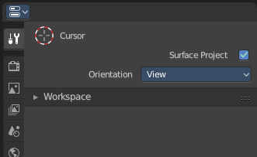
The Tools tab contains the tools settings for the currently active tool. For example when you have the Knife tool in edit mode selected, then you will find tool settings here. Or when you are in Vertex Paint, then you will find the paint tools here.
The content is also mode dependant. When you are in Edit mode with a mesh object, then you will have the Mesh options and the Normal Tools.
Something that is available in all modes is the Workspace panel.
The tool specific settings above the panels, in this case the Surface Project check box an dthe Orientation Dropdown box will be explained in the manual parts where this tools are covered. In the Tool shelf chapters.

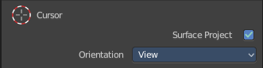
Tool settings area
In this area you will find the tool settings for the currently active tool.
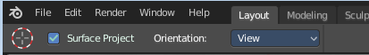
The display starts with the 3D cursor by default.

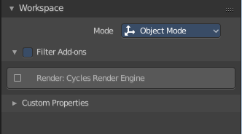
Workspace panel
Workspaces can be configured to start in specific modes and with a specific sets of active addons. This is the place where you configure this settings.
You have to save the startup file to make these changes permanent.

Mode
The mode in which the 3D view should start when you switch to this workspace layout.

Filter Addons
Here you can filter, means activate or deactivate specific addons.

Custom Properties
Custom properties allows you to store your own metadata. This metadata cna then be used for rigging and Python scripts.
Then following data supports custom properties:
- All data-blocks types.
- Bones and Pose-Bones.
- Sequence strips.

Mode specific panels
In Object mode you don't have any panels in the tools tab besides the Workspace panels. In all other modes you have specific panels that contains options and the tools settings.

Tools Tab and Top Bar

The content of the tools tab is identical to the content of the Top Bar. It's the same tool set. You can decide by yourself with which set you want to work. The Top bar can be hidden if you don't need it.

What is missing in the Top Bar is the Workspace settings.

This means that the documentation for the tools tab is also the documentation of the Top Bar.

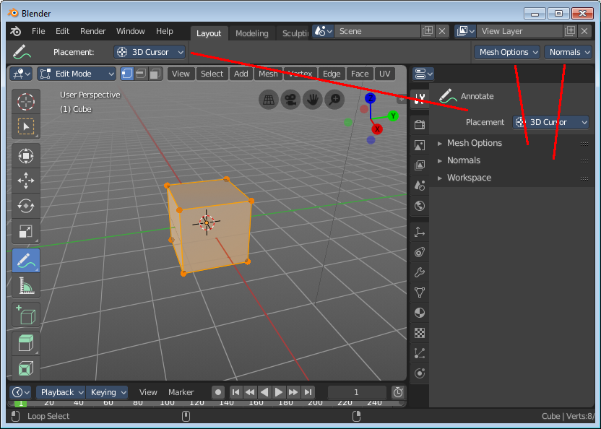

Edit Mode - Mesh Object

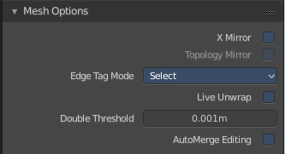
Mesh Options panel
Here you can find some mesh specific settings.

X Mirror
X Axis Mirror Editing.

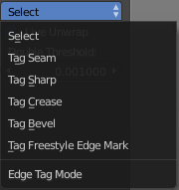
Topology Mirror
Use Topology based mirroring.

Edge Select Mode
Edge Select Mode is a drop-down box where you can choose the select method for edges.

Live Unwrap
Changing edges seam recalculates UV Unwrap.

Double Threshold
Limit for removing duplicates and 'Auto Merge'.

Auto Merge Editing
Automatically merge vertices that are close to each other.

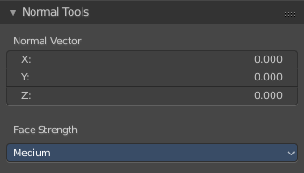
Normal Tools panel
Here you can find some normal related settings.
Not documented. Not to find out how to use. Waiting for the Blender documentation here ...

Edit Mode - Bezier Curve

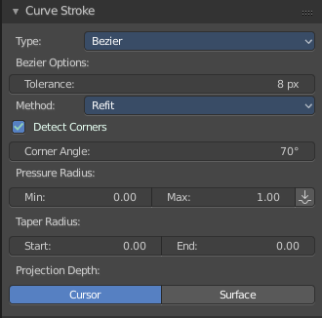
Curve Stroke Panel type Bezier

Type
Here you switch between the curve type Bezier and Poly.

Bezier Options

Tolerance
Allow deviation for a smoother but less precise line

Method
The curve fitting method. Here you can choose between Refit and Split.

Detect Corners
Detect corners and use non aligned angles.

Corner Angle
Corners above this angle are considered as corners.

Pressure Radius
Pressure radius is interesting when you use a tablet. Here you can adjust the Minimum and Maximum pressure radius. When you don't use a tablet then the maximum pressure value will be used.

Taper Radius
Taper factor for the radius of each point along the curve.

Projection depth
Here you can set the method of projection depth.

Cursor
Sets the projection depth to 3D Cursor.

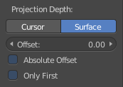
Surface
Sets the projection depth to Surface. Then the curve paints at a surface that is placed under the stroke. It also reveals some more settings for Projection Depth method Surface

Offset
Offset the stroke from the surface.

Absolute Offset
Apply a fixed offset.

Only First
Use the start of the stroke for depth.

Curve Stroke Panel type Poly

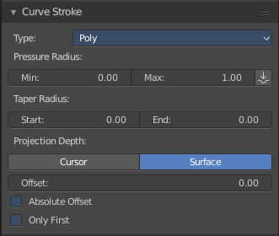
Type
Here you switch between the curve type Bezier and Poly.

Pressure Radius
Pressure radius is interesting when you use a tablet. Here you can adjust the Minimum and Maximum pressure radius. When you don't use a tablet then the maximum pressure value will be used.

Taper Radius
Taper factor for the radius of each point along the curve.

Projection depth
Here you can set the method of projection depth.

Cursor
Sets the projection depth to 3D Cursor.

Surface
Sets the projection depth to Surface. Then the curve paints at a surface that is placed under the stroke. It also reveals some more settings for Projection Depth method Surface

Offset
Offset the stroke from the surface

Absolute Offset
Apply a fixed offset

Only First
Use the start of the stroke for depth.

Edit Mode - Armature

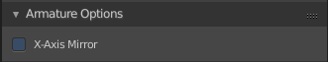
Armature Options panel

X Axis Mirror
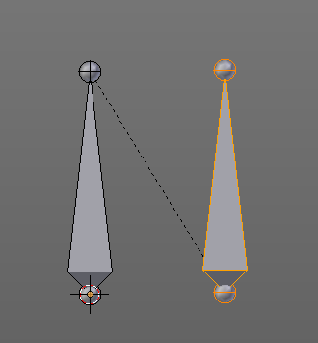
X Axis Mirror is made to sync the right side of a symmetrical armature with the left side of a symmetrical armature. Means you can create just one half of a skeleton. And then simply mirror it over to the other half. And any further changes that you do at the one side will also apply to the other side of the armature. This includes the whole FK IK setup. And can save you lots of work therefore.
To get X Axis mirror to work requires a bit preparation work.
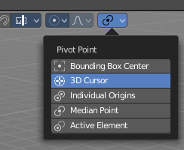
Create a armature, with some bones at the one side. Like this. The 3D cursor needs to be at 0/0/0. The left bone is in the middle. Think of it as the backbone. The right bone has an offset, and shall represent our right side of the armature.
Change the Pivot Point in the Header to 3D Cursor. Important step. We want to mirror around the 3D Cursor.
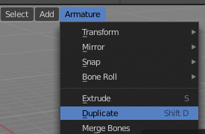
Now select the right side of the armature. Border select is one fast way. But NOT the bone in the middle, which is our backbone. We don't want to mirror this one too.

Duplicate what we have selected. And click immediately to leave the duplicate mode. Or you will pull the duplicated part around. Which is not what we want.

Next we will scale our new created armature part by -1 to mirror it over to the other side. Activate Scale, don't move the mouse, but type immediately in X for the axis and -1 for the scale factor.

This will create our mirrored armature part.

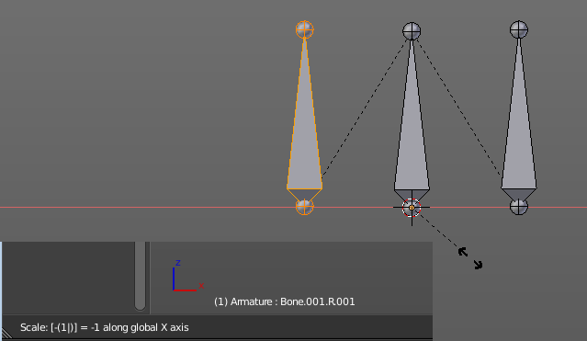

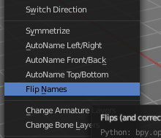

Next important step is to Flip Names. This renames the mirrored bones. Bone.001.R becomes without this step Bone.001.R.001. With rename we get Bone.001.L

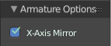
And now we are finally arrived at X Axis Mirror. Tick it.

Now you should be able to modify the one side of the armature, and the other side will be modified too. This includes as told above also FK IK set-ups that you do in Pose mode.

Pose Mode - Armature

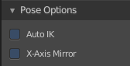
Pose Options Panel

Auto IK
Add temporary IK constraints while grabbing bones in Pose mode.

X Axis Mirror
X Axis Mirror is made to sync the right side of a symmetrical armature with the left side of a symmetrical armature.

Sculpt Mode

Sculpting is a process to deform the mesh geometry by using a brush.

In Sculpt Mode you will mainly find settings for the different brushes. General settings. And brush specific settings. This settings can be found in different panels. The different brushes have different options and settings, dependant of which brush is selected. This brush specific options and settings are explained in the tool shelf chapter. Here we just cover the general panels with options and settings that exists for (nearly) all brushes.

The Sculpt Mode just exists for Mesh objects.

Sculpt Mode - Brush Panel
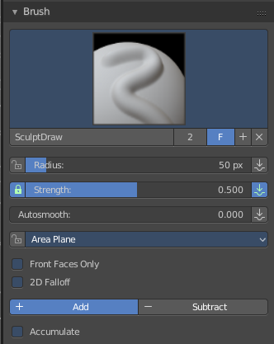

Brush Panel
The Brush Panel contains the different Sculpt Brushes and some Brush settings.

Browse Brush
The big image at the top is a dropdown box where you can choose a brush. Click at it, and you will see the different brushes. A click at one of the images will choose this brush then.

Persistent and Set Persistent Base is just available with the brush type Layer.
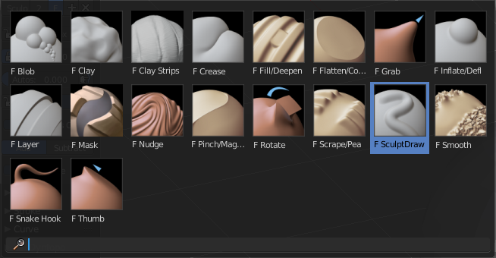
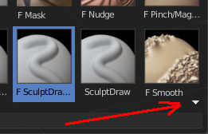
When you have added a few more brushes then the dropdown box may be more than full. You will see some little white arrows then. Either in the top left or in the bottom right corner. They indicate that some brushes are hidden before or after the current display.
To scroll to this hidden content use the mouse wheel, or the arrow up and down buttons at the keyboard.

The edit box below the Image shows you the name of the current active brush.
The number right of it, in this case 2, indicates how much number of users ( internally ) this brush uses. This means that this data block (the brush) shares currently settings with at least one other object. Most probably the parent brush where we have created it from. Click at the value to make this brush a single user. The button will vanish then.
F set the brush to have a fake user. Zero user data-blocks are normally not saved. But sometimes you want to force the data to be kept even when the data block has no user.
The + button allows you to add a new pencil with the current settings. Note that the brushes are NOT saved when you close Bforartists. You can save them into the current blend file. Or you can save the startup file. But be careful here. This saves everything else of the current state of Bforartists too.
The X button deletes the brush as the active one. It does NOT delete it from the brushes list.

Radius
The Radius edit box allows you to adjust the radius of the brush. When the Lock symbol at the front is ticked, then the pencil keeps its size relative to the object when zooming in and out. The button behind the edit box enables tablet pressure sensitivity for radius.
And the button at the end allows you to set the radius of the pencil by hotkey. A click at this button works of course too. But this is a hotkey tool. The button is just a visible reminder.

Strength
The Strength edit box allows you to adjust the strength of the brush. When the Lock symbol at the front is ticked, then the pencil keeps its strength relative to the object when zooming in and out. The button behind the edit box enables tablet pressure sensitivity for strength.
And the button at the end allows you to set the strength by hotkey. A click at this button works of course too. But this is a hotkey tool. The button is just a visible reminder.

Autosmooth
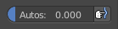
The autosmooth edit box allows you to adjust the amout of smoothing that gets automatically applied to each stroke. The button behind the edit box enables tablet pressure sensitivity for autosmooth.

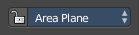
Sculpt Plane
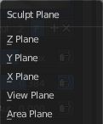
The sculpt plane defines how the sculpting is aligned. It is a dropdown box where you can choose different methods. By default the Area Plane gets used.
When the Lock symbol at the front is ticked, then it keeps using the normal of the surface where the stroke was initiated.

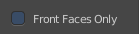
Front Faces Only
Front Faces only means that the stroke just affects the vertices that are pointing forwards to the camera.

2D Falloff
Apply the brush influence in 2d circle instead of a sphere.

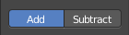
Add / Subtract
Add means the stroke adds to the geometry. Subtract means the stroke subtracts from the geometry.

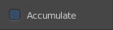
Accumulate, Persistent, etc.
In this area below the add and subtract buttons you will find the brush related settings. They differ from brush to brush.

Sculpt Mode - Overlay Panel

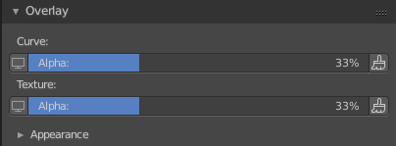
Curve
This setting is interesting for the Stroke method Curve. Here you can adjust how transparent the curve is.
The eye icon button in front of the slider is to show the curve object in viewport. The brush icon button behind the slider is to hide the overlay during a stroke.

Texture
This setting is interesting for Texture painting. Here you can adjust how transparent the texture is.
The eye icon button in front of the slider is to show the texture in the viewport. The brush icon button behind the slider is to hide the overlay during a stroke.
The Stencil map texture has no eye icon button since it gets shown in the viewport anyways.

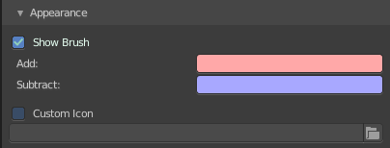
Appearance
The Appearance subtab provides you with some settings to adjust the appearance of the brush.

Show Brush
Show the brush in 3D view.

Add
The color that the brush cursor has when adding to geometry.

Subtract
The color of the brush cursor when subtracting from the geometry.

Custom Brush Icon
Here you can define a custom icon for the brush.

Sculpt Mode - Texture Panel
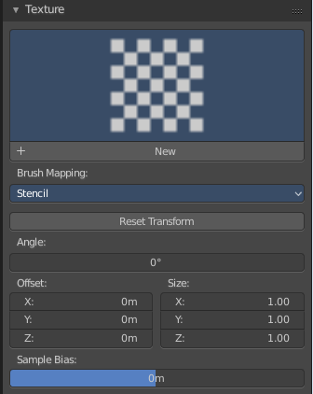
The Texture panel allows you to sculpt with textures. This allows you for example to grab a foto from some fish scales, and simply sculpt them into the surface of your object by using this image as a pencil. Or as a blueprint where you calk through ( Stencil method ).

Note that the following shots are made with Symmetry off and without Brush falloff. Since they disturbed.

Symmetry can be turned off here:

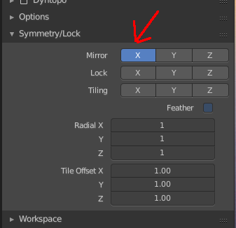
And the brush falloff can be adjusted here. Choose the last method here to have no falloff towards the borders of the brush.

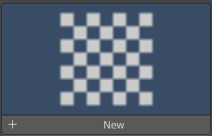
Browse Texture to be linked
The image at the top of the panel is a image browser. Here you can choose a texture that you can choose for sculpting then. You can also have more than one image loaded at once.

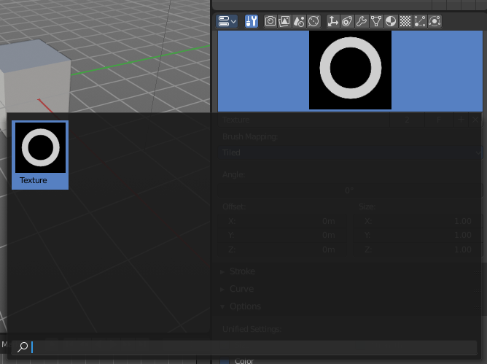
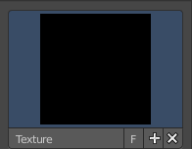
In this shot there is already a texture added. The way to add the texture here is a bit more complicated. And not done with clicking at the New button.

First click at the New button below the image. This will create a new texture slot. This slot is still empty, it displays black.

We need to load the texture in this slot. This must be done in the Properties editor in the Textures tab. And then the texture finally shows in the Texture panel in the Tool Shelf.
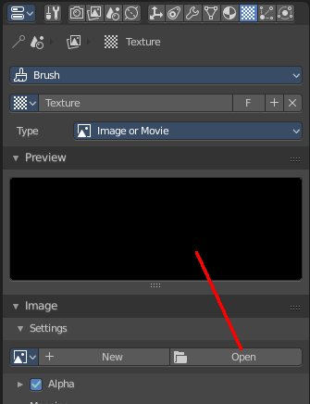
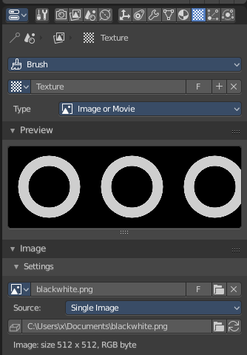
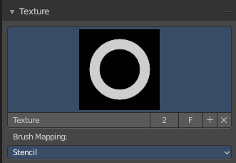

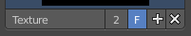
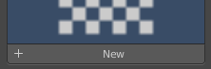
Texture Edit box
The Texture edit box is the edit box below the Image browser. When there's no image loaded then it displays the New button. When there's a image (or more) loaded, then you will see the name of the current texture.
The F button turns this texture into a data block with a fake user. Means it will exists even when there is no data connected to it anymore.
When you activate Fake User, then you may get a value in front of it, which displays how much users this data block (our texture slot) currently has.
The + Button adds another texture slot. Note that you will have to load a texture too, as explained above.
The X button deletes the texture slot.

Brush Mapping
Our texture can be mapped in different methods. The Brush mapping is a dropdown box where you can choose this different brush mapping methods.
The settings vary. So we will go through them by the different brush mapping methods.

Brush Mapping with mapping method View Plane and Area Plane
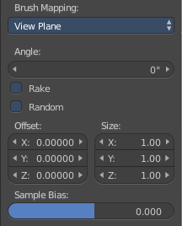
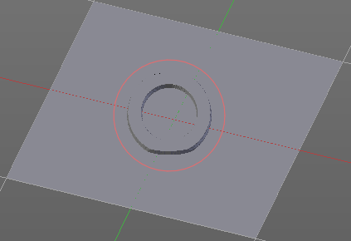
The brush mapping method View Plane maps the brush onto the surface of the object, calculating the mapping from the current view. The result may be distorted when the view does not align with the surface of the object.
The brush mapping method Area Plane maps the brush onto the surface of the object, calculating the mapping from the current view. The result is not distorted.

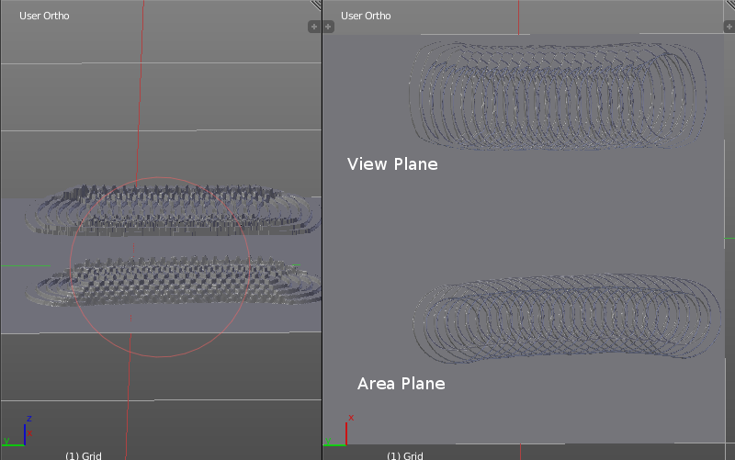
Angle edit box
Here you can adjust the angle of the brush.

Rake
The angle follows the direction of the brush stroke.

Random
The brush angle gets set random.

Random edit box
Becomes visible when you tick Random. Here you can adjust the maximum value of the random angle.

Offset
Fine tune the offset of the texture in the brush.

Size
Fine tune the size of the texture in the brush.

Sample Bias
Here you can add to or subtract from the amount that gets added by the brush texture.

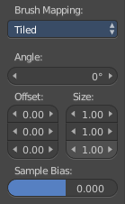
Brush Mapping with mapping method Tiled
The brush mapping method View Plane maps the brush onto the surface of the object, and tiles the pencil onto the surface. The mapping happens from the View plane. Means you get distortions when you sculpt from an angle.
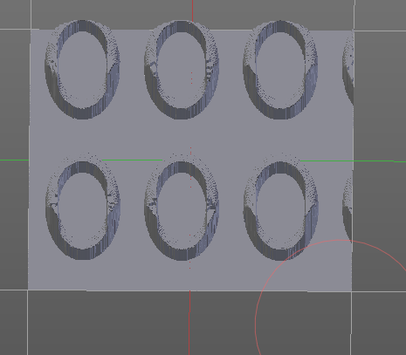

Angle edit box
Here you can adjust the angle of the brush.

Offset
Fine tune the offset of the texture in the brush.

Size
Fine tune the size of the texture in the brush.

Sample Bias
Here you can add to or subtract from the amount that gets added by the brush texture.

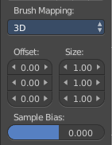
Brush Mapping with mapping method 3D
The brush mapping method View Plane and Area Plane sculpts where the pencil is. The method 3D sculpts at the initial position of the pencil, as long as you don't release the mouse. The mapping happens from the View plane. Means you get distortions when you sculpt from an angle.

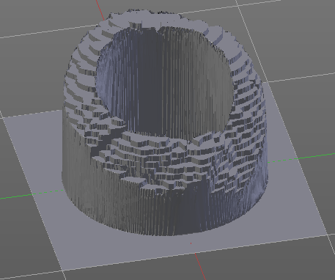
Offset
Fine tune the offset of the texture in the brush.

Size
Fine tune the size of the texture in the brush.

Sample Bias
Here you can add to or subtract from the amount that gets added by the brush texture.

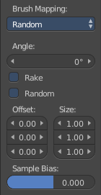
Brush Mapping with mapping method Random
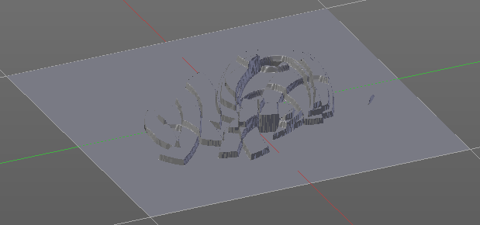
The brush mapping method Random randomizes the texture position of the pencil texture. And so it sculpts random fragments of the pencil.

Angle edit box
Here you can adjust the angle of the brush.

Rake
The angle follows the direction of the brush stroke.

Random
The brush angle gets set random.

Random edit box
Becomes visible when you tick Random. Here you can adjust the maximum value of the random angle.

Offset
Fine tune the offset of the texture in the brush.

Size
Fine tune the size of the texture in the brush.

Sample Bias
Here you can add to or subtract from the amount that gets added by the brush texture.

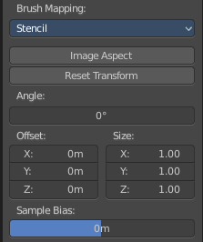
Brush Mapping with mapping method Stencil
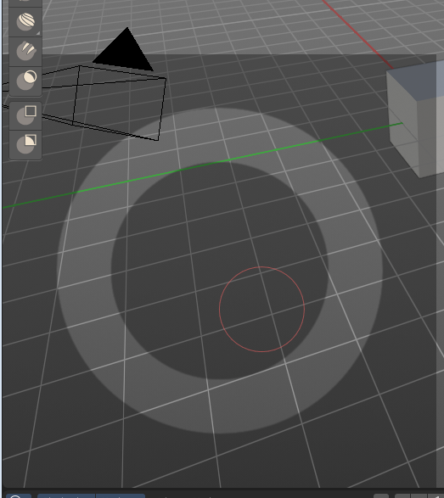
The former methods uses the textures for the brush. The method Stencil works different. You have your texture displayed in the workspace above the object, and you paint this texture onto your object with your pencil strokes.
Note that the texture in the 3d space is just visible when you are with the mouse over the viewport.

Image Aspect
Adjust the stencil size to fit to the image aspect ratio.
------------------------------------------------------------
Not yet. Needs reimplementation!!

Stencil Brush controls
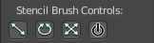
Here you can move, rotate and scale the stencil image in the 3D viewport. And reset the transform. You better use the hotkeys here that gets displayed in the tool tips, since the image is not displayed when the mouse is not over the 3D viewport.
----------------------------------------------------

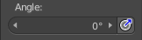
Angle edit box
Here you can adjust the angle of the brush. The button at the end allows you to set the radius by dragging the mouse. This should be done in the viewport and with the hotkey. This button is just a visible reminder.

Offset
Fine tune the offset of the texture in the brush.
------------------------------------------------------------
Not yet. Needs reimplementation!!

Size
Fine tune the size of the texture in the brush.
------------------------------------------------------------

Sculpt Mode - Stroke Panel
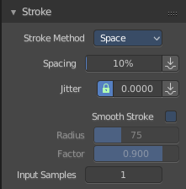
The Stroke panel contains settings to influence the behaviour of the brush stroke. There are various stroke methods available. We will go through them one by one.

Stroke Panel with Stroke method Space
This is the default Stroke method. The sculpt stroke gets added continuously with given settings.
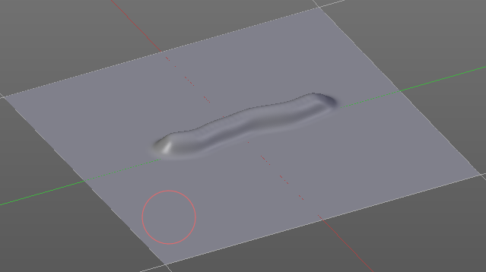

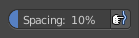
Spacing Edit Box
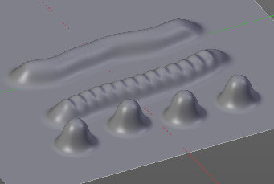
The sculpt drawing happens by mapping the pencil onto the mouse position. And when you move the mouse then the next mapping happens. Here you can adjust the spacing after what mouse movement the next mapping should happen. The lower the value, the lower the distance between the single dots.
The icon behind the edit box enables tablet pressure sensitivity for tablets.

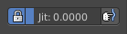
Jitter Edit Box
Here you can add Jitter to the brush while painting.
The icon in front of the edit box toggles between jittering in screen space and relative to brush size.
The icon behind the edit box enables tablet pressure sensitivity for tablets.

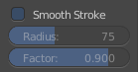
Smooth Stroke
The brush lags behind the mouse position, and produces a much smoother stroke by that.

Smooth Stroke Radius Edit Box
Is just active when Smooth Stroke is activated. Here you can adjust the radius of the smoothing.

Smooth Stroke Factor Edit Box
Is just active when Smooth Stroke is activated. Here you can adjust the factor of the smoothing.

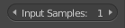
Input Samples Edit Box
Average multiple input samples together to smooth the brush stroke.

Stroke Panel with Stroke method Curve
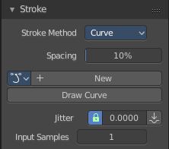
The Stroke method curve doesn't simply influence the way how the stroke is painted. It is a special method. First you draw a curve object by holding down ctrl and clicking with left mouse button. Then you tweak the curve. You can click at the curve point, and drag out handlers to make the curve points smoooth
Then you hit the Draw Curve button. And the curve gets sculpted.

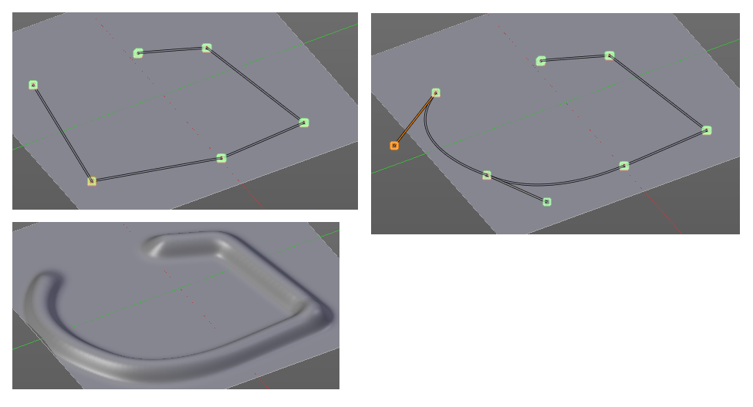

Spacing Edit Box
The sculpt drawing happens by mapping the pencil onto the mouse position. And when you move the mouse then the next mapping happens. Here you can adjust the spacing after what mouse movement the next mapping should happen. The lower the value, the lower the distance between the single dots.
The icon behind the edit box enables tablet pressure sensitivity for tablets.

Paint Curve edit box
Here you set the active curve.
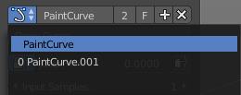
The first element is a dropdown box where you will find your curves objects. You can have more than one.
The second element is the edit box that displays the active curve.
The number right of it, in this case 2, indicates how much number of users ( internally ) this brush uses. This means that this data block (the brush) shares currently settings with at least one other object. Most probably the parent brush where we have created it from. Click at the value to make this brush a single user. The button will vanish then.
F set the brush to have a fake user. Zero user data-blocks are normally not saved. But sometimes you want to force the data to be kept even when the data block has no user.

The + button allows you to add a new pencil with the current settings. Note that the brushes are NOT saved when you close Bforartists. You can save them into the current blend file. Or you can save the startup file. But be careful here. This saves everything else of the current state of Bforartists too.
The X button deletes the brush as the active one. It does NOT delete it from the brushes list.

Draw Curve Button
A click at it to turns the curve into a sculpt stroke.

Jitter Edit Box
Here you can add Jitter to the brush while painting.
The icon in front of the edit box toggles between jittering in screen space and relative to brush size.
The icon behind the edit box enables tablet pressure sensitivity for tablets.

Input Samples Edit Box
Average multiple input samples together to smooth the brush stroke.

Stroke Panel with Stroke method Line
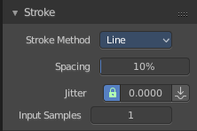
With Stroke method line you draw a line between a starting point and a endpoint. And when you release the mouse then the line gets sculpted.

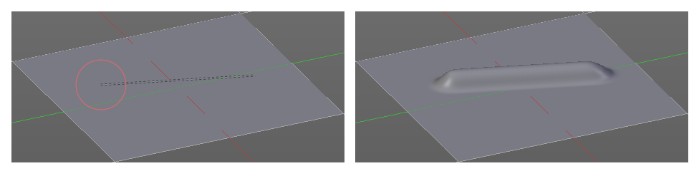

Spacing Edit Box
The sculpt drawing happens by mapping the pencil onto the mouse happens. Here you can adjust the spacing after what mouse movement the next mapping should happen. The lower the value, the lower the distance between the single dots.
The icon behind the edit box enables tablet pressure sensitivity for tablets.

Jitter Edit Box
Here you can add Jitter to the brush while painting.
The icon in front of the edit box toggles between jittering in screen space and relative to brush size.
The icon behind the edit box enables tablet pressure sensitivity for tablets.

Input Samples Edit Box
Average multiple input samples together to smooth the brush stroke.

Stroke Panel with Stroke method Airbrush
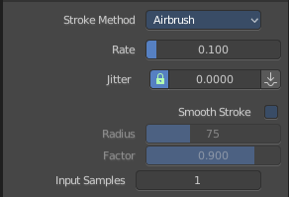
The sculpt stroke acts like an airbrush pencil. The dots gets placed randomly.
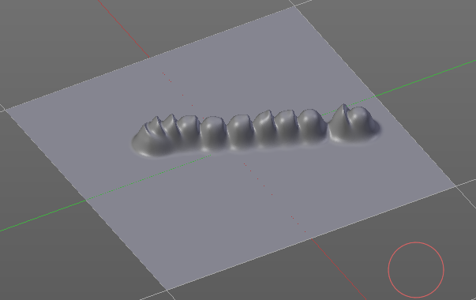

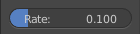
Rate Edit Box
Here you can define the rate of the drawing.

Jitter Edit Box
Here you can add Jitter to the brush while painting.
The icon in front of the edit box toggles between jittering in screen space and relative to brush size.
The icon behind the edit box enables tablet pressure sensitivity for tablets.

Smooth Stroke
The brush lags behind the mouse position, and produces a much smoother stroke by that.

Smooth Stroke Radius Edit Box
Is just active when Smooth Stroke is activated. Here you can adjust the radius of the smoothing.

Smooth Stroke Factor Edit Box
Is just active when Smooth Stroke is activated. Here you can adjust the factor of the smoothing.

Input Samples Edit Box
Average multiple input samples together to smooth the brush stroke.

Stroke Panel with Stroke method Anchored
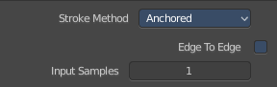
Click and drag to place a dot and to scale it.

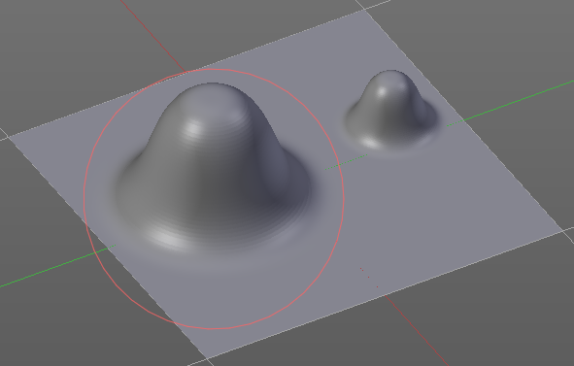

Edge to Edge
Without Edge to Edge the scaling happens from the center of the brush. With edge to edge the scaling happesn from the edge of the brush.

Input Samples Edit Box
Average multiple input samples together to smooth the brush stroke.

Stroke Panel with Stroke method Drag dot
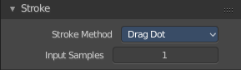
Click and drag to place a dot.

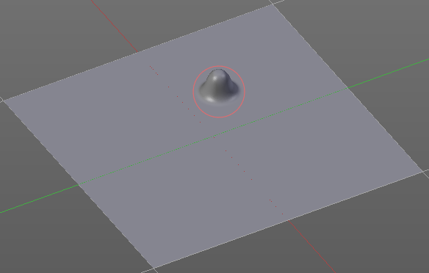

Input Samples Edit Box
Average multiple input samples together to smooth the brush stroke.

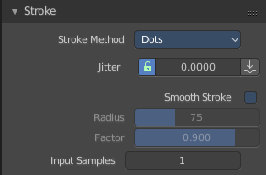
Stroke Panel with Stroke method dot
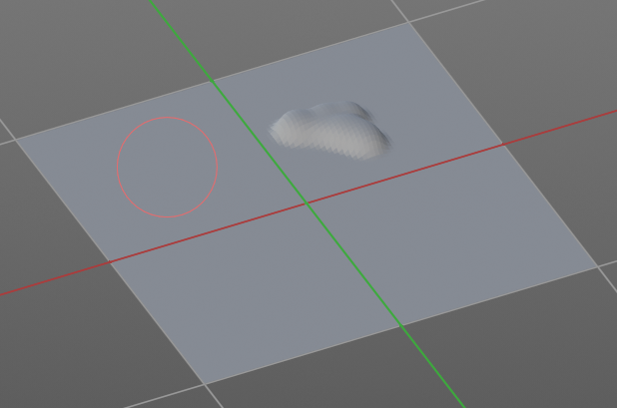

Jitter Edit Box
Here you can add Jitter to the brush while painting.
The icon in front of the edit box toggles between jittering in screen space and relative to brush size.
The icon behind the edit box enables tablet pressure sensitivity for tablets.

Smooth Stroke
The brush lags behind the mouse position, and produces a much smoother stroke by that.

Smooth Stroke Radius Edit Box
Is just active when Smooth Stroke is activated. Here you can adjust the radius of the smoothing.

Smooth Stroke Factor Edit Box
Is just active when Smooth Stroke is activated. Here you can adjust the factor of the smoothing.

Input Samples Edit Box
Average multiple input samples together to smooth the brush stroke.

Sculpt Mode - Curve Panel
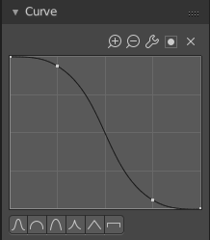
The curve panel allows you to define different fallofs methods for the border of the brush.

Navigation elements
The navigation elements at the top are described from left to right.

Zoom in and out
The two buttons with the magnifying glass at it zooms in and out in the curve window.

Tools
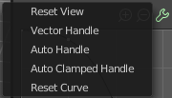
Tools is a menu where you can find some cuve related tools.

Reset View
Resets the curve windows zoom.

Vector Handle
Set handle type to Vector.

Auto Handle
Set handle type to Auto.

Auto Clamped Handle
Set handle type to Auto Clamped.

Reset Curve
Resets the curve to the initial shape.

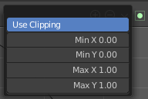
Use Clipping
Clipping options. Here you can set up clipping for the stroke.

Delete Points
Deletes selected curve points

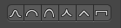
Curve Presets
Here you can find some predefined curve presets.

Sculpt Mode - Dyntopo Panel

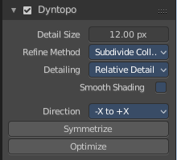
Dyntopo Panel
Dyntopo stands for Dynamic Topology Sculpting.
Without dyntopo you just deform the existing geometry. With Dyntopo geometry gets subdivided when needed. This makes it possible to sculpt complex shapes out of a block.
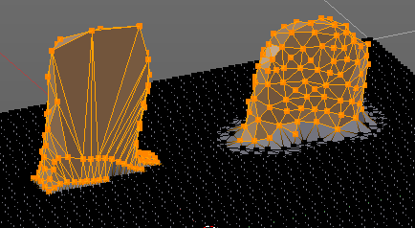
Left without Dyntopo, right with Dyntopo.
Note that some brushes does not work with Dyntopo. They are Grab brush, Rotate brush, Thumb brush, Layer brush, Smooth brush (including alt-key smoothing with a different brush) and Mask brush.
The topology will also not be updated if the stroke mode is Anchored or Drag Dot.

Detail Size
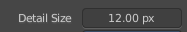
The Detail size defines how fine the subdivision will be.
The edit box below does the same. But with a slider, and without visible feedback in form of a widget.

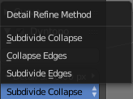
Detail Refine method
Here you can define the Detail refine method.

Subdivide Collapse
Both methods in one. Subdivide long edges to add mesh detail where needed. And collapse short edges to remove mesh detail where possible.

Collapse Edges
Collapse short edges to remove mesh detail where possible.

Subdivide Edges
Subdivide long edges to add mesh detail where needed.

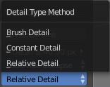
Detail Type Method
Here you can define the Detail Type method.

Brush Detail
Mesh Detail is relative to brush radius.

Constant Detail
Mesh detail is constant in object space according to detail size.

Relative Detail
Mesh Detail is relative to brush size and detail size

Smooth shading
Show faces in smooth shading instead of flat shading.

Direction
Source and Destination for Symmetrize operator. This has to do with the symmetrize button below.

Symmetrize
Symmetrize the topology modifications.

Optimize
Recalculate the sculpt BVH to improve performance.

Sculpt Mode - Options Panel

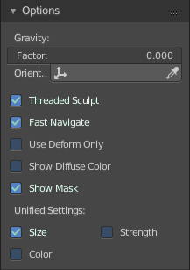
Gravity
Here you can add gravity after each stroke.

Factor
The factor silder defines the amount.

Orientation
Here you define an object that gets used to determine the gravity from. The Z axis of this object gets used.

Threaded Sculpt
Use multiple CPU cores for sculpting.

Fast Navigate
For Multires, show Low Res mesh when navigating.

Use Deform only
Use only deformation modifiers ( The other constructive modifiers except multi-resolution gets temporary disabled)

Show Diffuse Color
Show the diffuse color of the object while sculpting.

Show Mask
Show mask as overlay on object.

Unified Settings

Size
Instead of per Brush radius, the radius is shared across brushes.

Strength
Instead of per Brush strength, the strength is shared across brushes.

Color
Instead of per Brush color, the color is shared across brushes.

Sculpt Mode - Symmetry / Lock Panel
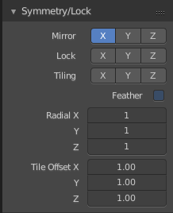
The Symmetry Lock panel contains tools around symmetry and lock features. Here you can turn on or off mirroring along axis, etc.

Mirror
Mirror sculpt along activated axis. By default the mirroring is activated around X axis.

Lock
Disallow vertices movement in locked axis direction.

Tiling
Produces a mesh that is tilable in the activated directions.

Feather
Reduce the strength of the brush where it overlaps symmetrical daubs

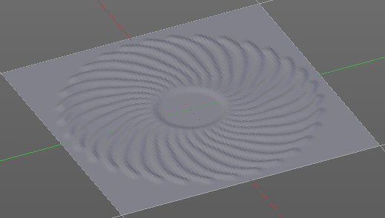
Radial
Adjust the repeatings across some axis. For example, when you change Z to 32, then you can draw 32 segments simultaneously around the Z axis instead of just one, distributed around the Z axis.

Tile Offset
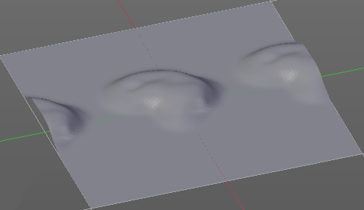
Here you can adjust the offset of the tiling.

Vertex Paint Mode

The Vertex paint allows you to color the vertices of a mesh.

In Vertex Paint Mode you will mainly find settings for the different brushes. General settings. And brush specific settings. This settings can be found in different panels. The brush specific options and settings are explained in the tool shelf chapter. Here we just cover the general panels.

The Sculpt Mode just exists for Mesh objects.

Vertex Paint Mode - Brush Panel

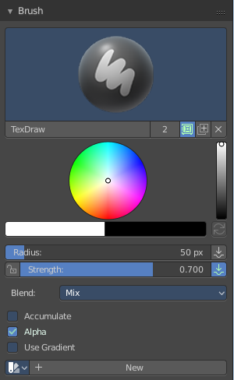
Brush Panel
The Brush Panel contains the different Brushes and some Brush settings. Here you can choose and adjust your current active brush.
At down left you can find the display options. The button with the gear symbol at it. Here you will find two toggles to hide away the color picker and the palette edit box.

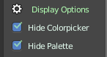

Browse Brush
The big image at the top is a dropdown box where you can choose a brush. Click at it, and you will see the different brushes. A click at one of the images will choose this brush then.
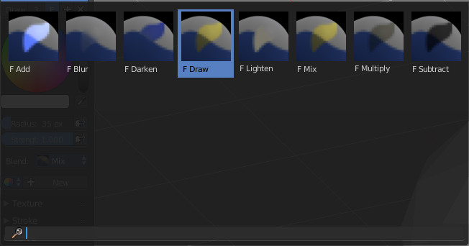
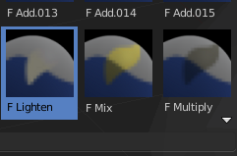
When you have added a few more brushes then the dropdown box may be more than full. You will see some little white arrows then. Either in the top left or in the bottom right corner. They indicate that some brushes are hidden before or after the current display.
To scroll to this hidden content use the mouse wheel, or the arrow up and down buttons at the keyboard.
The edit box below the Image shows you the name of the current active brush.
The number right of it, in this case 2, indicates how much number of users ( internally ) this brush uses. This means that this data block (the brush) shares currently settings with at least one other object. Most probably the parent brush where we have created it from. Click at the value to make this brush a single user. The button will vanish then.
F set the brush to have a fake user. Zero user data-blocks are normally not saved. But sometimes you want to force the data to be kept even when the data block has no user.
The + button allows you to add a new pencil with the current settings. Note that the brushes are NOT saved when you close Bforartists. You can save them into the current blend file. Or you can save the startup file. But be careful here. This saves everything else of the current state of Bforartists too.
The X button deletes the brush as the active one. It does NOT delete it from the brushes list.

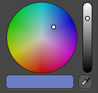
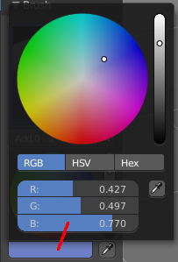
Color dialog
The color dialog is hidden by default. See display options at the bottom of the panel. You can define the color in the color element below the brush browser. It will also open a color dialog then.
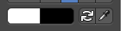

When you set it to visible, then you can set the color for painting by a click with the mouse in the color wheel. The slider at the right defines the brightness.
The button below shows you the active color.
A click at the color button will open a more detailed color dialog, where you can set up rgb, hsv and hex colors and with sliders.

Color Element
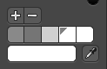
Here you can set a primary and a secondary color. The button with the arrows at it switches the active and the secondary color. And with the pipette you can pick a color from the screen. This will reveal some more elements, and create a palette. Here you can choose now the color to use it for painting. You can add and remove colors here too.
This color picker can just pick a color in the 3D view. It does not work elsewhere.

Radius
The Radius edit box allows you to adjust the radius of the brush. The button behind the edit box enables tablet pressure sensitivity for radius.
And the button at the end allows you to set the radius of the pencil by hotkey. A click at this button works of course too. But this is a hotkey tool. The button is just a visible reminder.

Strength
The Strength edit box allows you to adjust the strength of the brush. The button behind the edit box enables tablet pressure sensitivity for strength.
And the button at the end allows you to set the strength by hotkey. A click at this button works of course too. But this is a hotkey tool. The button is just a visible reminder.

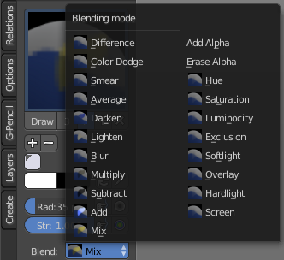
Blending Modes
Here you can define how the stroke will blend.

Accumulate, Alpha, etc.
This are brush specific settings. They change with the brush.

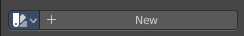
Palette Editbox
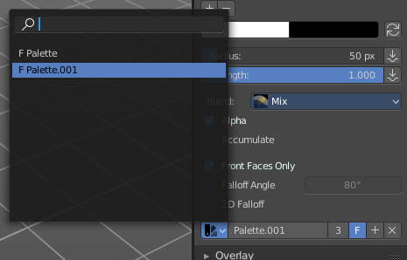
Palette Edit box is hidden by default.
Here you can give your palette a name, create another palette, remove palette, and give it a fake user.


Display options
Here you can show or hide the Colorpicker and the Palette Editbox.

Vertex Paint Mode - Overlay Panel

Curve
This setting is interesting for the Stroke method Curve. Here you can adjust how transparent the curve is.
The eye icon button in front of the slider is to show the curve object in viewport. The brush icon button behind the slider is to hide the overlay during a stroke.

Texture
This setting is interesting for Texture painting. Here you can adjust how transparent the texture is.
The eye icon button in front of the slider is to show the texture in the viewport. The brush icon button behind the slider is to hide the overlay during a stroke.
The Stencil map texture has no eye icon button since it gets shown in the viewport anyways.

Appearance
The Appearance subtab provides you with some settings to adjust the appearance of the brush.

Show Brush
Show the brush in 3D view.

Add
The color that the brush cursor has when adding to geometry.

Subtract
The color of the brush cursor when subtracting from the geometry.

Custom Brush Icon
Here you can define a custom icon for the brush.

Vertex Paint Mode - Texture Panel

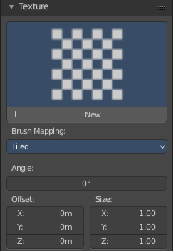
The Texture panel allows you to paint with textures. This allows you for example to grab a foto from some fish scales, and simply paint them onto the vertices by using this image as a pencil. Or as a blueprint where you calk through ( Stencil method ).

Browse Texture to be linked
The image at the top of the panel is a image browser. Here you can choose a texture that you can choose for vertex painting then. You can also have more than one image loaded at once.

In this shot there is already a texture added. The way to add the texture here is a bit more complicated. And not done with clicking at the New button.

First click at the New button below the image. This will create a new texture slot. This slot is still empty, it displays black.

We need to load the texture in this slot. This must be done in the Properties editor in the Textures tab. And then the texture finally shows in the Texture panel in the Tool Shelf.

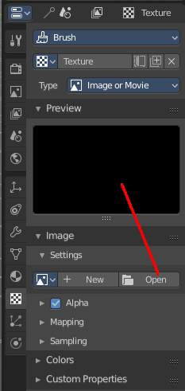
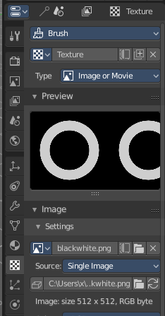
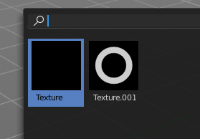
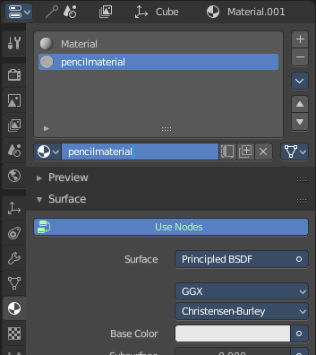

Texture Edit box
The Texture edit box is the edit box below the Image browser. When there's no image loaded then it displays the New button. When there's a image (or more) loaded, then you will see the name of the current texture.
The F button turns this texture into a data block with a fake user. Means it will exists even when there is no data connected to it anymore.
When you activate Fake User, then you may get a value in front of it, which displays how much users this data block (our texture slot) currently has.
The + Button adds another texture slot. Note that you will have to load a texture too, as explained above.
The X button deletes the texture slot.

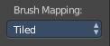
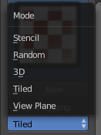
Brush Mapping
Our texture can be mapped in different methods. The Brush mapping is a dropdown box where you can choose this different brush mapping methods.
The settings vary. So we will go through them by the different brush mapping methods.

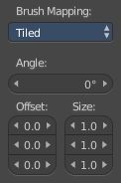
Brush Mapping with mapping method Tiled
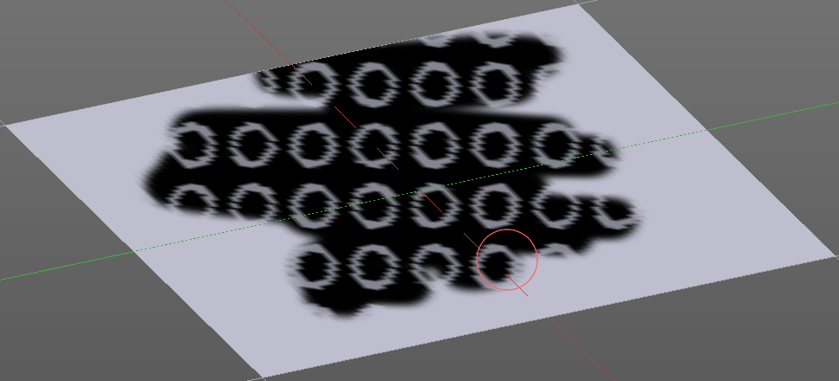
The brush mapping method Tiled tiles the brush stroke at the surface. The mapping happens from the current view. The result may be distorted when the view does not align with the surface of the object.

Angle
The angle of the brush.

Offset
The offset of the texture in the brush.

Size
The size of the texture in the brush.

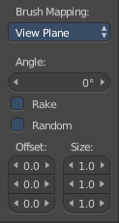
Brush Mapping with mapping method View Plane
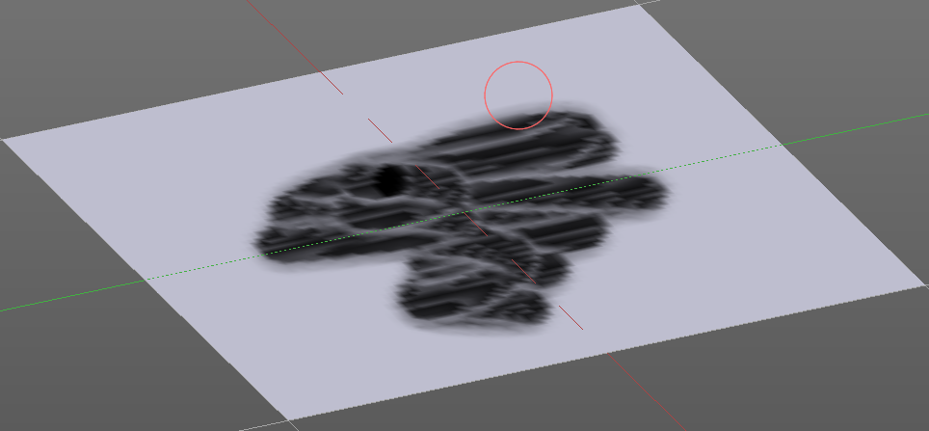
The brush mapping method View Plane simply paints onto the surface. The mapping happens from the current view. The result may be distorted when the view does not align with the surface of the object.

Angle
The angle of the brush.

Rake
The angle follows the direction of the brush stroke.

Random
The brush angle gets set random.

Offset
The offset of the texture in the brush.

Size
The size of the texture in the brush.

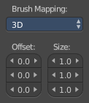
Brush Mapping with mapping method 3D
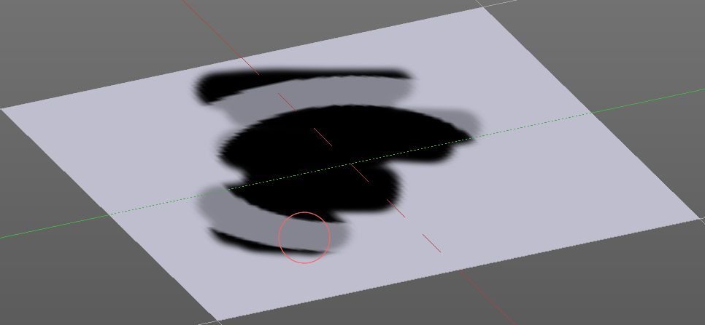
The brush mapping method 3D paints the texture at the surface, by tiling it 1/1 at the object surface.

Offset
The offset of the texture in the brush.

Size
The size of the texture in the brush.

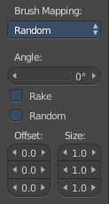
Brush Mapping with mapping method Random
The brush mapping method Random paints onto the surface, and randomizes the texture position in the brush while that. The mapping happens from the current view. The result may be distorted when the view does not align with the surface of the object.

Angle
The angle of the brush.

Rake
The angle follows the direction of the brush stroke.

Random
The brush angle gets set random.

Offset
The offset of the texture in the brush.

Size
The size of the texture in the brush.

Brush Mapping with mapping method Stencil
The former methods uses the textures for the brush. The method Stencil works different. You have your texture displayed in the workspace above the object, and you paint this texture onto your object with your pencil strokes.
Note that the texture in the 3d space is just visible when you are with the mouse over the viewport.

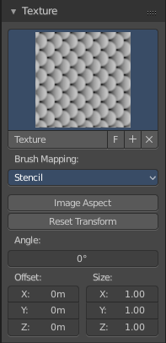
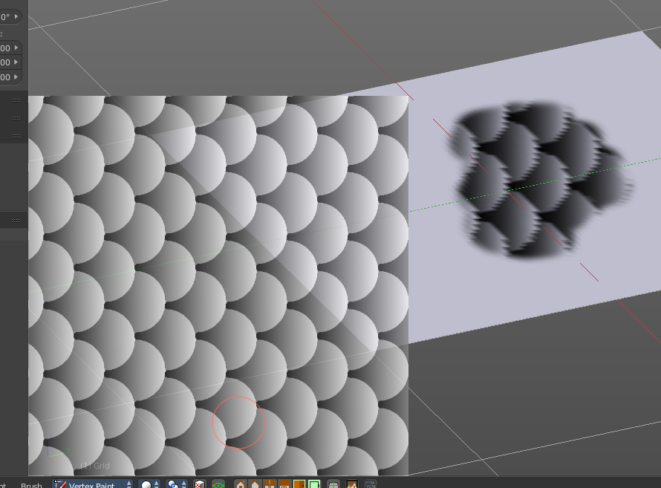
Image Aspect
Adjust the stencil size to fit to the image aspect ratio.

Reset Transform
Resets all transforms.

Stencil Brush controls
Not yet!
Here you can move, rotate and scale the stencil image in the 3D viewport. And reset the transform. You better use the hotkeys here that gets displayed in the tool tips, since the image is not displayed when the mouse is not over the 3D viewport.

Angle edit box
Here you can adjust the angle of the brush. The button at the end allows you to set the radius by dragging the mouse. This should be done in the viewport and with the hotkey. This button is just a visible reminder.

Offset
Fine tune the offset of the texture in the brush.

Size
Fine tune the size of the texture in the brush.

Vertex Paint Mode - Stroke Panel

The Stroke panel contains settings to influence the behaviour of the brush stroke. There are various stroke methods available. We will go through them one by one.

Stroke Panel with Stroke method Space
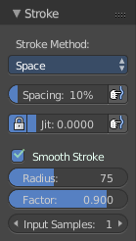
This is the default Stroke method. The sculpt stroke gets added continuously with given settings.
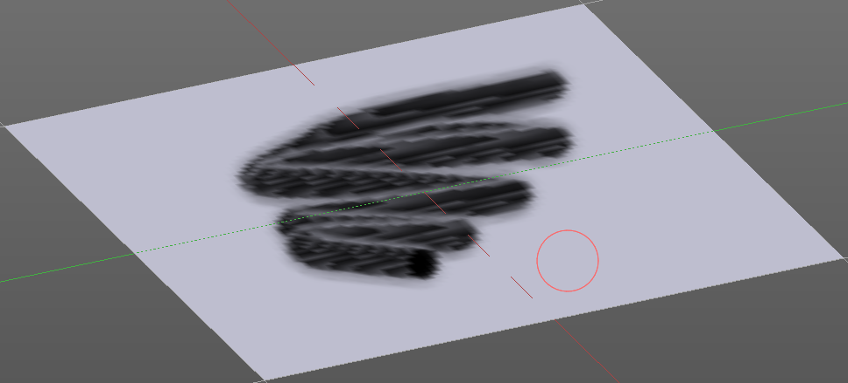

Spacing Edit Box
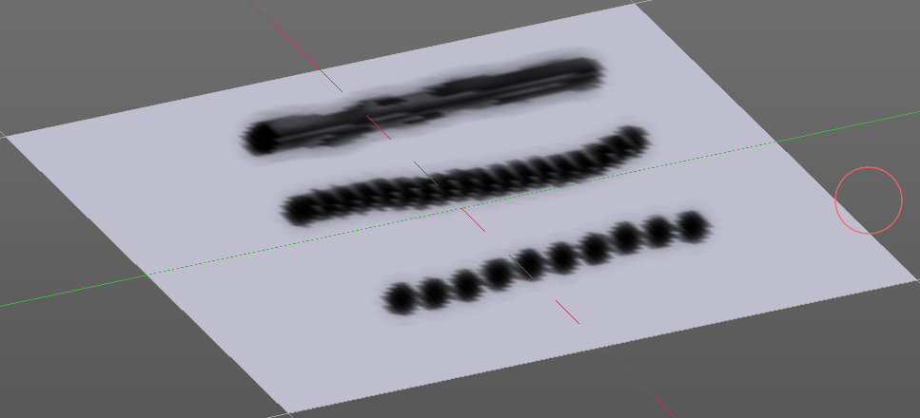
The sculpt drawing happens by mapping the pencil onto the mouse position. And when you move the mouse then the next mapping happens. Here you can adjust the spacing after what mouse movement the next mapping should happen. The lower the value, the lower the distance between the single dots.
The icon behind the edit box enables tablet pressure sensitivity for tablets.

Jitter Edit Box
Here you can add Jitter to the brush while painting.
The icon in front of the edit box toggles between jittering in screen space and relative to brush size.
The icon behind the edit box enables tablet pressure sensitivity for tablets.

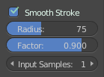
Smooth Stroke
The brush lags behind the mouse position, and produces a much smoother stroke by that. The Smooth Stroke relatet settings are hidden as long as Smooth Stroke is not activated.

Smooth Stroke Radius Edit Box
Is just active when Smooth Stroke is activated. Here you can adjust the radius of the smoothing.

Smooth Stroke Factor Edit Box
Is just active when Smooth Stroke is activated. Here you can adjust the factor of the smoothing.

Input Samples Edit Box
Is just active when Smooth Stroke is activated. Average multiple input samples together to smooth the brush stroke.

Stroke Panel with Stroke method Curve
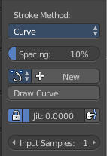
The Stroke method curve doesn't simply influence the way how the stroke is painted. It is a special method. First you draw a curve object by holding down ctrl and clicking with left mouse button. Then you tweak the curve. You can click at the curve point, and drag out handlers to make the curve points smoooth.
Then you hit the Draw Curve button. And the curve gets drawn onto the surface.

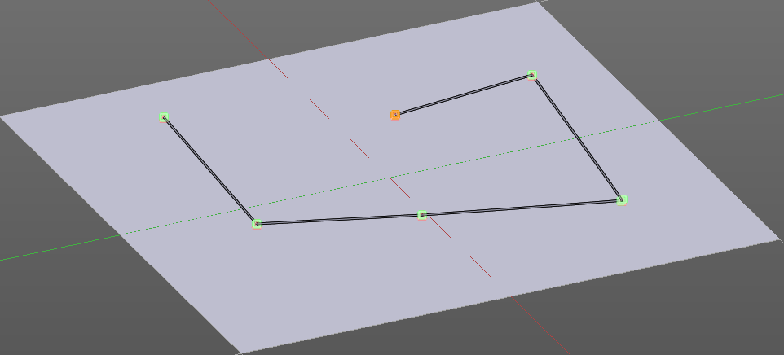
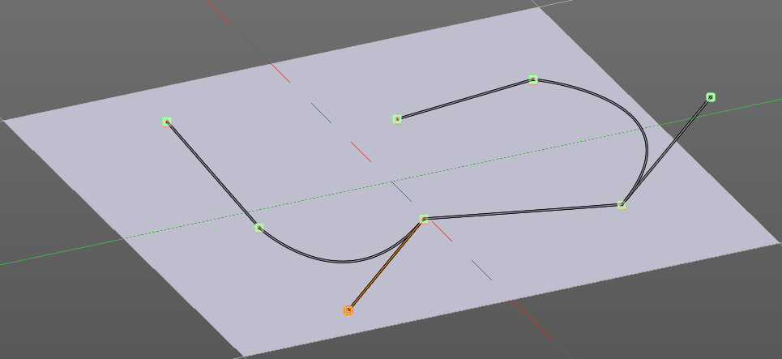
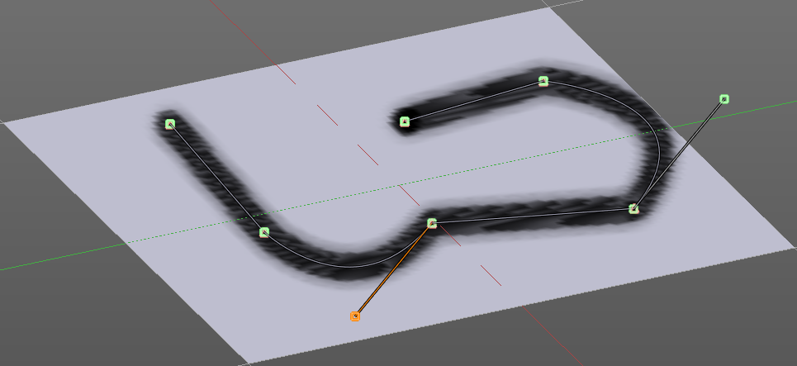

Spacing Edit Box
The drawing happens by mapping the pencil onto the mouse position. And when you move the mouse then the next mapping happens. Here you can adjust the spacing after what mouse movement the next mapping should happen. The lower the value, the lower the distance between the single dots.
The icon behind the edit box enables tablet pressure sensitivity for tablets.

Paint Curve edit box
Here you set the active curve.
The first element is a dropdown box where you will find your curves objects. You can have more than one.
The second element is the edit box that displays the active curve.
The number right of it, in this case 2, indicates how much number of users ( internally ) this brush uses. This means that this data block (the brush) shares currently settings with at least one other object. Most probably the parent brush where we have created it from. Click at the value to make this brush a single user. The button will vanish then.
F set the brush to have a fake user. Zero user data-blocks are normally not saved. But sometimes you want to force the data to be kept even when the data block has no user.
The + button allows you to add a new pencil with the current settings. Note that the brushes are NOT saved when you close Bforartists. You can save them into the current blend file. Or you can save the startup file. But be careful here. This saves everything else of the current state of Bforartists too.
The X button deletes the brush as the active one. It does NOT delete it from the brushes list.

Draw Curve Button
A click at it to turns the curve into a sculpt stroke.

Jitter Edit Box
Here you can add Jitter to the brush while painting.
The icon in front of the edit box toggles between jittering in screen space and relative to brush size.
The icon behind the edit box enables tablet pressure sensitivity for tablets.

Input Samples Edit Box
Average multiple input samples together to smooth the brush stroke.

Stroke Panel with Stroke method Line
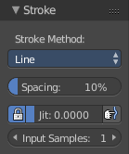
With Stroke method line you draw a line between a starting point and a endpoint. And when you release the mouse then the line gets sculpted.

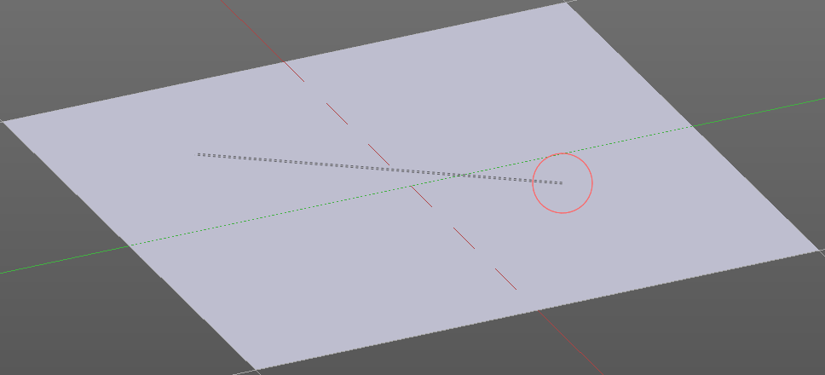
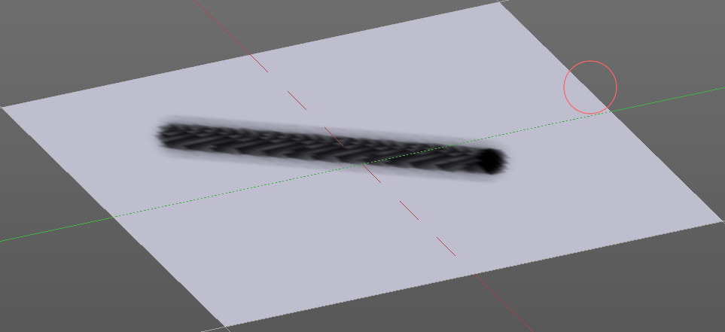

Spacing Edit Box
The sculpt drawing happens by mapping the pencil onto the mouse position. And when you move the mouse then the next mapping happens. Here you can adjust the spacing after what mouse movement the next mapping should happen. The lower the value, the lower the distance between the single dots.
The icon behind the edit box enables tablet pressure sensitivity for tablets.

Jitter Edit Box
Here you can add Jitter to the brush while painting.
The icon in front of the edit box toggles between jittering in screen space and relative to brush size.
The icon behind the edit box enables tablet pressure sensitivity for tablets.

Input Samples Edit Box
Average multiple input samples together to smooth the brush stroke.

Stroke Panel with Stroke method Airbrush
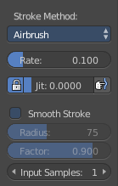
The stroke acts like an airbrush pencil. The dots gets placed randomly.
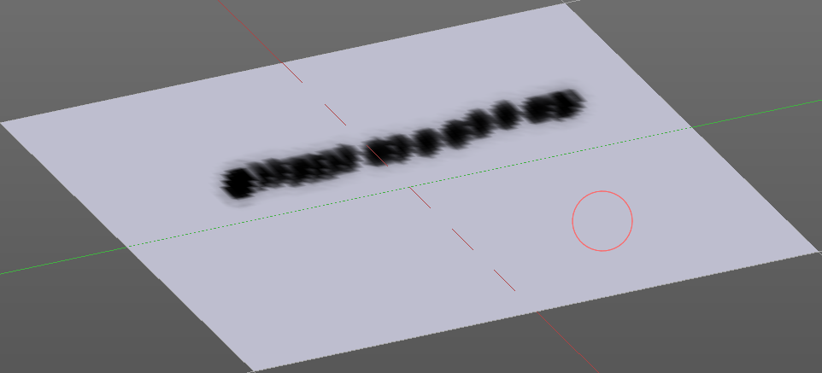

Rate Edit Box
Here you can define the rate of the drawing.

Jitter Edit Box
Here you can add Jitter to the brush while painting.
The icon in front of the edit box toggles between jittering in screen space and relative to brush size.
The icon behind the edit box enables tablet pressure sensitivity for tablets.

Smooth Stroke
The brush lags behind the mouse position, and produces a much smoother stroke by that.

Smooth Stroke Radius Edit Box
Is just active when Smooth Stroke is activated. Here you can adjust the radius of the smoothing.

Smooth Stroke Factor Edit Box
Is just active when Smooth Stroke is activated. Here you can adjust the factor of the smoothing.

Input Samples Edit Box
Average multiple input samples together to smooth the brush stroke.

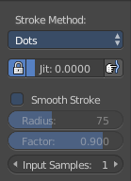
Stroke Panel with Stroke method Dots
The stroke method Dots draws dots of the pencil onto the surface. The mapping happens from the current view. Means you will get distortions when your view is not aligned with the surface of the object.

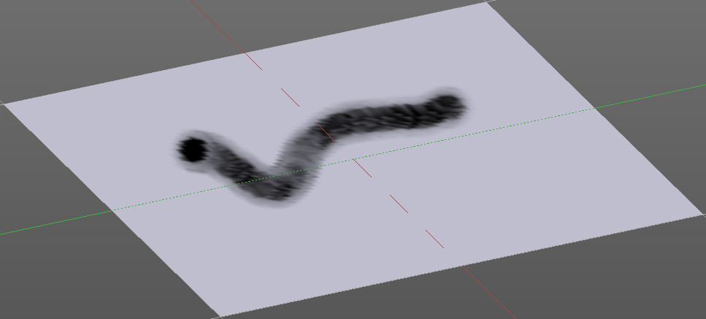
Jitter Edit Box
Here you can add Jitter to the brush while painting.
The icon in front of the edit box toggles between jittering in screen space and relative to brush size.
The icon behind the edit box enables tablet pressure sensitivity for tablets.

Smooth Stroke
The brush lags behind the mouse position, and produces a much smoother stroke by that.

Smooth Stroke Radius Edit Box
Is just active when Smooth Stroke is activated. Here you can adjust the radius of the smoothing.

Smooth Stroke Factor Edit Box
Is just active when Smooth Stroke is activated. Here you can adjust the factor of the smoothing.

Input Samples Edit Box
Average multiple input samples together to smooth the brush stroke.

Vertex Paint Mode - Curve Panel
The curve panel allows you to define different fallofs methods for the border of the brush.

Navigation elements
The navigation elements at the top are described from left to right.

Zoom in and out
The two buttons with the magnifying glass at it zooms in and out in the curve window.

Tools
Tools is a menu where you can find some cuve related tools.

Reset View
Resets the curve windows zoom.

Vector Handle
Set handle type to Vector.

Auto Handle
Set handle type to Auto.

Auto Clamped Handle
Set handle type to Auto Clamped.

Reset Curve
Resets the curve to the initial shape.

Use Clipping
Clipping options. Here you can set up clipping for the stroke.

Delete Points
Deletes selected curve points

Curve Presets
Here you can find some predefined curve presets.

Vertex Paint Mode - Options Panel

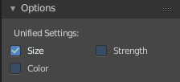
Unified Settings

Size
Instead of per Brush radius, the radius is shared across brushes.

Strength
Instead of per Brush strength, the strength is shared across brushes.

Color
Instead of per Brush color, the color is shared across brushes.

Vertex Paint Mode - Symmetry Panel
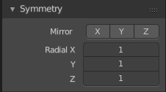

Mirror
Mirror along given axis.

Radial
Tiling. The number of times to repeat the strokes across the surface.

Weight Paint Mode

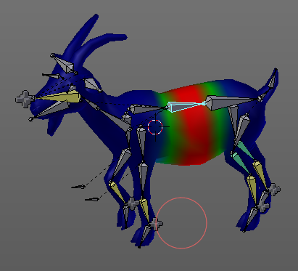
The Tool Shelf in Weight Paint Mode provides you the tools to do weight painting at a mesh. Skinned characters for example.
The vertices becomes a "weighting" assigned in this process. Means a per centage influence of the bone to a vertice. And under the hood you create vertex groups with the vertices that are assigned to the bones.
The amount of influence is defined by the weight paint color. Pure red has an influence value of 1. Pure blue has an influence value of 0. And the gradients between red and blue defines the inbetween steps in the 0-1 range. This is needed since there can be more than one bone influence and deform a vertice. Usually at the transition areas between two bones. The green areas in this shot.
The Weight Paint mode is just available for mesh objects.

Weight painting at characters
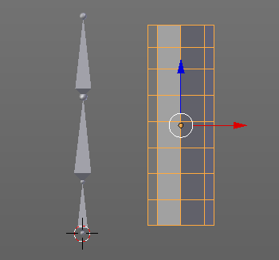
The main purpose for Weightpainting is to weight the skin for characters. So that they deform proper when you pose your armature.

Skinning
To do weightpainting at a character you first have to assign the skin to the armature. So we need a mesh and a armature here.
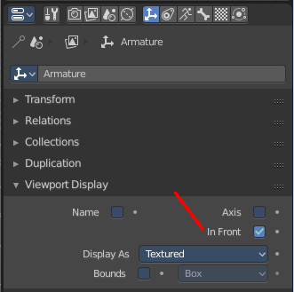
Let's do a quick run through skinning. This method works in Object mode, but also in Pose mode.
First we activate Display "in Front" for the armature. So that we can still see the armature inside of the mesh.
Position the mesh at its final location.
Now select the Mesh, hold down Shift key, and select the Armature. Both should be selected now.
Dive into the Object menu, and search for Parent, with automatic weights. You can also press the hotkey Ctrl P. This calls the parenting menu under the mouse position.
Here we choose "With Automatic Weights". Automatic weighting means that the bones grabs the nearest vertices within a given radius, and assignes them to this bone.
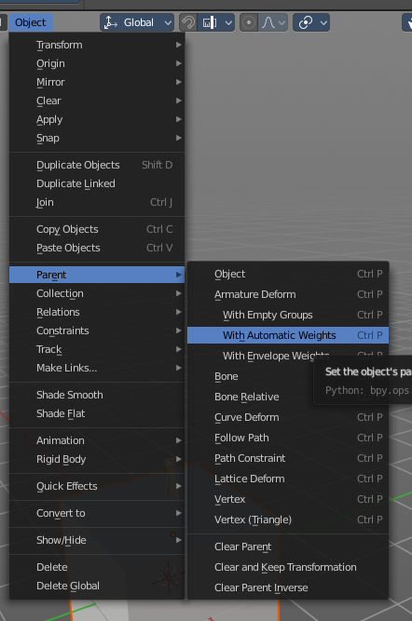
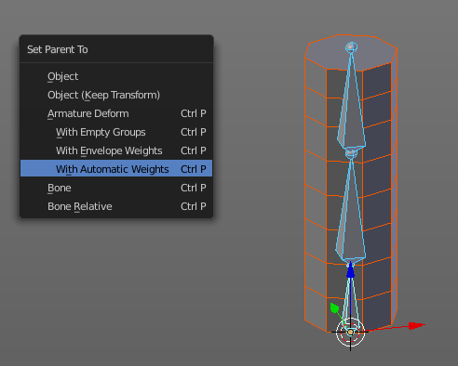

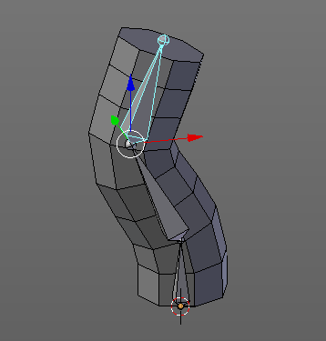

When everything went well then the mesh, in our case the Cylinder, is now part of the hierarchy of the armature.
And when you select the armature, and switch to Pose mode now, then you can already deform the mesh by posing the armature.

Enter and leave Weight painting
You can enter Weight Painting for the mesh in any state of the armature. But weight painting should happen in Pose mode so that you can pose your mesh to see the resulting deformings.
So with the armature in Pose mode, select the mesh by clicking at it. Then enter Weight Paint mode. You can now do weight painting at the mesh.
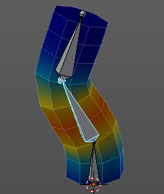
To leave Weight painting, simply switch back to Object mode.

Switch bones
The weighting that gets displayed when you enter Weight Paint mode is from the last active bone. You might want to do weight painting for another bone. So we need to switch the bone.
Hold down Ctrl, and click at the bone that you want to set active. Then the weighting for this bone gets displayed.

Weight painting a plain mesh
You can also do weightpainting without an armature. Just at the pure mesh. In this case you just create the vertex groups for the mesh. And those vertex groups can be accessed in edit mode then for further useage. As shown in the shots below.
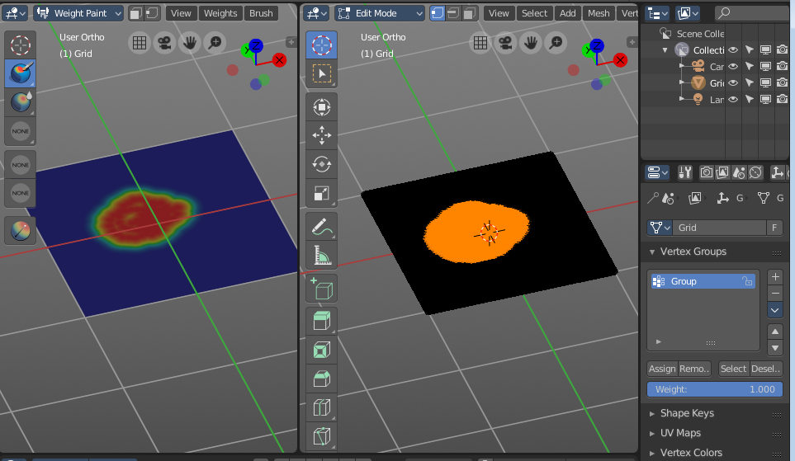

Weight painting in combination with particles
You can also combine weight painting with particles. To influence the densitry of hair for example. The weightmap can be assigned in the Vertex Groups panel in the Particles tab.
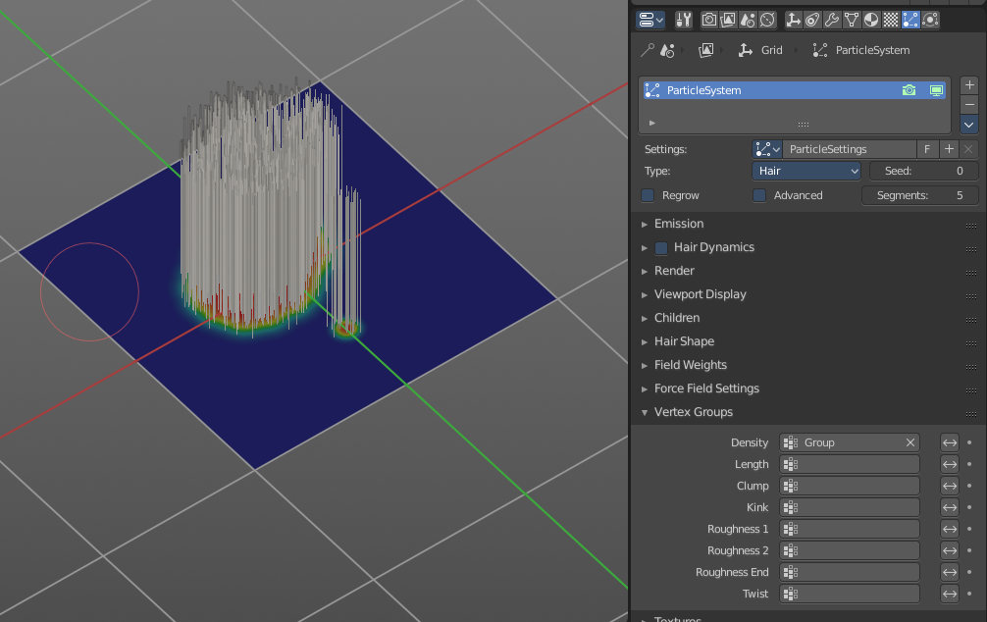

Weight Paint Mode - Brush Panel

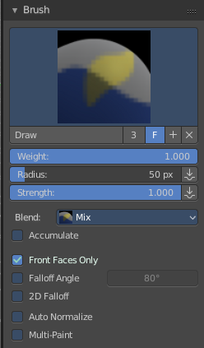
Brush Panel
The Brush Panel contains the different Brushes and some Brush settings. Here you can choose and adjust your current active brush.

Browse Brush
The big image at the top is a dropdown box where you can choose a brush. Click at it, and you will see the different brushes. A click at one of the images will choose this brush then.
When you have added a few more brushes then the dropdown box may be more than full. You will see some little white arrows then. Either in the top left or in the bottom right corner. They indicate that some brushes are hidden before or after the current display.
To scroll to this hidden content use the mouse wheel, or the arrow up and down buttons at the keyboard.
The edit box below the Image shows you the name of the current active brush.
The number right of it, in this case 2, indicates how much number of users ( internally ) this brush uses. This means that this data block (the brush) shares currently settings with at least one other object. Most probably the parent brush where we have created it from. Click at the value to make this brush a single user. The button will vanish then.
F set the brush to have a fake user. Zero user data-blocks are normally not saved. But sometimes you want to force the data to be kept even when the data block has no user.
The + button allows you to add a new pencil with the current settings. Note that the brushes are NOT saved when you close Bforartists. You can save them into the current blend file. Or you can save the startup file. But be careful here. This saves everything else of the current state of Bforartists too.
The X button deletes the brush as the active one. It does NOT delete it from the brushes list.

Weight edit box
Here you can adjust the strength of the weight painting.

Radius
The Radius edit box allows you to adjust the radius of the brush. The button behind the edit box enables tablet pressure sensitivity for radius.
And the button at the end allows you to set the radius of the pencil by hotkey. A click at this button works of course too. But this is a hotkey tool. The button is just a visible reminder.

Strength
The Strength edit box allows you to adjust the strength of the brush. The button behind the edit box enables tablet pressure sensitivity for strength.
And the button at the end allows you to set the strength by hotkey. A click at this button works of course too. But this is a hotkey tool. The button is just a visible reminder.

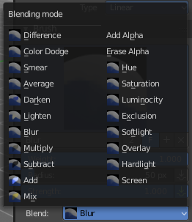
Blend
Blend is a dropdown box where you can choose between different blend modes for the color that you paint.

Accumulate
Accumulate stroke daubts on top of each other

Front Faces Only
The Brush only paints at faces that faces to the view.

Falloff Angle
Blend Brush influence by the angle to the front.

2D Falloff
Apply brush influence in 2D circle instead of a sphere.

Auto Normalize
Auto normalizes the weighting so that in the sum all vertex groups does not go over 1.0

Multipaint
Paint across the weights of all selected bones, maintaining their relative influence.

Tools Tab - Weight Paint Mode - Overlay Panel

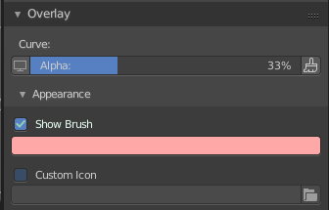
Curve
This setting is interesting for the Stroke method Curve. Here you can adjust how transparent the curve is.
The eye icon button in front of the slider is to show the curve object in viewport. The brush icon button behind the slider is to hide the overlay during a stroke.

Appearance
The Appearance subtab provides you with some settings to adjust the appearance of the brush.

Show Brush
Show the brush in 3D view.

Add
The color that the brush cursor has.

Custom Brush Icon
Here you can define a custom icon for the brush.

Tools Tab - Weight Paint Mode - Stroke Panel

Stroke Panel
The Stroke panel contains settings to influence the behaviour of the brush stroke. There are various stroke methods available. We will go through them one by one.

Stroke Panel with Stroke method Space
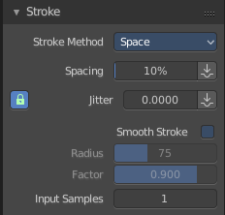
This is the default Stroke method. The sculpt stroke gets added continuously with given settings.
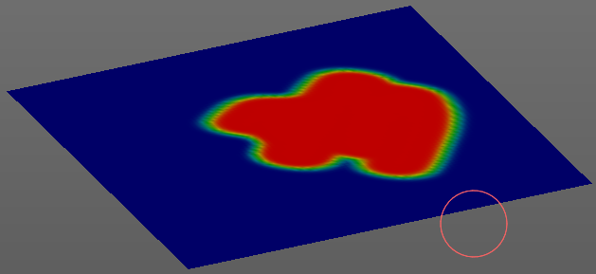

Spacing Edit Box
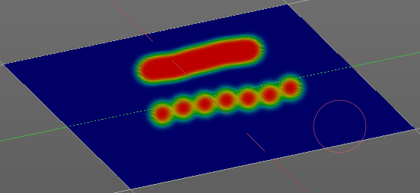
The drawing happens by mapping the pencil onto the mouse position. And when you move the mouse then the next mapping happens. Here you can adjust the spacing after what mouse movement the next mapping should happen. The lower the value, the lower the distance between the single dots.
The icon behind the edit box enables tablet pressure sensitivity for tablets.

Jitter Edit Box
Here you can add Jitter to the brush while painting.
The icon in front of the edit box toggles between jittering in screen space and relative to brush size.
The icon behind the edit box enables tablet pressure sensitivity for tablets.

Smooth Stroke
The brush lags behind the mouse position, and produces a much smoother stroke by that.

Smooth Stroke Radius Edit Box
Is just active when Smooth Stroke is activated. Here you can adjust the radius of the smoothing.

Smooth Stroke Factor Edit Box
Is just active when Smooth Stroke is activated. Here you can adjust the factor of the smoothing.

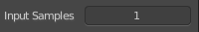
Input Samples Edit Box
Average multiple input samples together to smooth the brush stroke.

Stroke Panel with Stroke method Curve
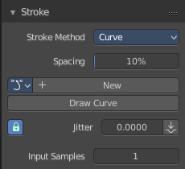
The Stroke method curve doesn't simply influence the way how the stroke is painted. It is a special method. First you draw a curve object by holding down ctrl and clicking with left mouse button. Then you tweak the curve. You can click at the curve point, and drag out handlers to make the curve points smoooth.
Then you hit the Draw Curve button. And the curve gets drawn onto the surface.
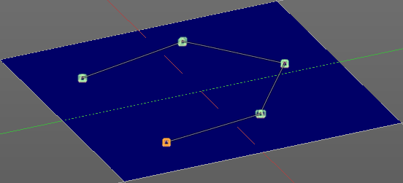
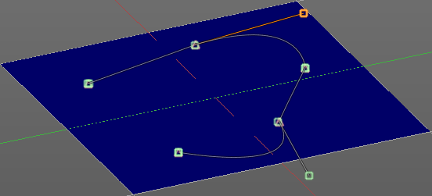
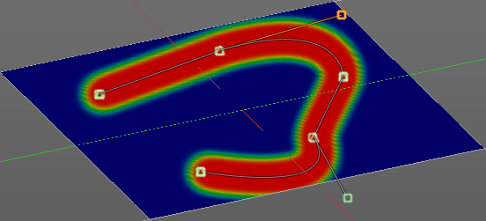

Spacing Edit Box
The drawing happens by mapping the pencil onto the mouse position. And when you move the mouse then the next mapping happens. Here you can adjust the spacing after what mouse movement the next mapping should happen. The lower the value, the lower the distance between the single dots.
The icon behind the edit box enables tablet pressure sensitivity for tablets.

Paint Curve edit box
Here you set the active curve.
The first element is a dropdown box where you will find your curves objects. You can have more than one.
The second element is the edit box that displays the active curve.
The number right of it, in this case 2, indicates how much number of users ( internally ) this brush uses. This means that this data block (the brush) shares currently settings with at least one other object. Most probably the parent brush where we have created it from. Click at the value to make this brush a single user. The button will vanish then.
F set the brush to have a fake user. Zero user data-blocks are normally not saved. But sometimes you want to force the data to be kept even when the data block has no user.
The + button allows you to add a new pencil with the current settings. Note that the brushes are NOT saved when you close Bforartists. You can save them into the current blend file. Or you can save the startup file. But be careful here. This saves everything else of the current state of Bforartists too.
The X button deletes the brush as the active one. It does NOT delete it from the brushes list.

Draw Curve Button
A click at it to turns the curve into a sculpt stroke.

Jitter Edit Box
Here you can add Jitter to the brush while painting.
The icon in front of the edit box toggles between jittering in screen space and relative to brush size.
The icon behind the edit box enables tablet pressure sensitivity for tablets.

Input Samples Edit Box
Average multiple input samples together to smooth the brush stroke.

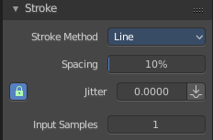
Stroke Panel with Stroke method Line
With Stroke method line you draw a line between a starting point and a endpoint. And when you release the mouse then the line gets sculpted.

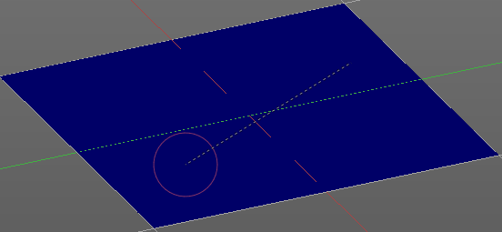
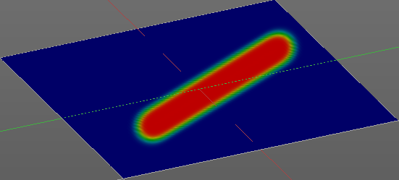

Spacing Edit Box
The sculpt drawing happens by mapping the pencil onto the mouse position. And when you move the mouse then the next mapping happens. Here you can adjust the spacing after what mouse movement the next mapping should happen. The lower the value, the lower the distance between the single dots.
The icon behind the edit box enables tablet pressure sensitivity for tablets.

Jitter Edit Box
Here you can add Jitter to the brush while painting.
The icon in front of the edit box toggles between jittering in screen space and relative to brush size.
The icon behind the edit box enables tablet pressure sensitivity for tablets.

Input Samples Edit Box
Average multiple input samples together to smooth the brush stroke.

Stroke Panel with Stroke method Airbrush
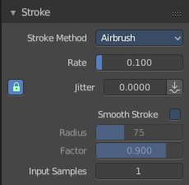
The stroke acts like an airbrush pencil. The dots gets sprayed randomly.
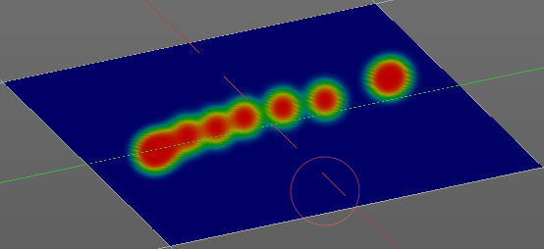

Rate Edit Box
Here you can define the rate of the drawing.

Jitter Edit Box
Here you can add Jitter to the brush while painting.
The icon in front of the edit box toggles between jittering in screen space and relative to brush size.
The icon behind the edit box enables tablet pressure sensitivity for tablets.

Smooth Stroke
The brush lags behind the mouse position, and produces a much smoother stroke by that.

Smooth Stroke Radius Edit Box
Is just active when Smooth Stroke is activated. Here you can adjust the radius of the smoothing.

Smooth Stroke Factor Edit Box
Is just active when Smooth Stroke is activated. Here you can adjust the factor of the smoothing.

Input Samples Edit Box
Average multiple input samples together to smooth the brush stroke.

Stroke Panel with Stroke method Dots
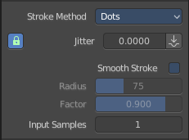
The stroke method Dots draws dots of the pencil onto the surface. The mapping happens from the current view. Means you will get distortions when your view is not aligned with the surface of the object.

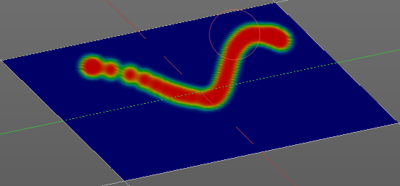
Jitter Edit Box
Here you can add Jitter to the brush while painting.
The icon in front of the edit box toggles between jittering in screen space and relative to brush size.
The icon behind the edit box enables tablet pressure sensitivity for tablets.

Smooth Stroke
The brush lags behind the mouse position, and produces a much smoother stroke by that.

Smooth Stroke Radius Edit Box
Is just active when Smooth Stroke is activated. Here you can adjust the radius of the smoothing.

Smooth Stroke Factor Edit Box
Is just active when Smooth Stroke is activated. Here you can adjust the factor of the smoothing.

Input Samples Edit Box
Average multiple input samples together to smooth the brush stroke.

Tools Tab - Weight Paint Mode - Curve Panel
The curve panel allows you to define different fallofs methods for the border of the brush.

Navigation elements
The navigation elements at the top are described from left to right.

Zoom in and out
The two buttons with the magnifying glass at it zooms in and out in the curve window.

Tools
Tools is a menu where you can find some cuve related tools.

Reset View
Resets the curve windows zoom.

Vector Handle
Set handle type to Vector.

Auto Handle
Set handle type to Auto.

Auto Clamped Handle
Set handle type to Auto Clamped.

Reset Curve
Resets the curve to the initial shape.

Use Clipping
Clipping options. Here you can set up clipping for the stroke.

Delete Points
Deletes selected curve points

Curve Presets
Here you can find some predefined curve presets.

Tools Tab - Weight Paint Mode - Symmetry Panel
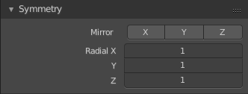

Mirror
Mirror along given axis.

Radial
Tiling. The number of times to repeat the strokes across the surface.

Tools Tab - Weight Paint Mode - Options Panel

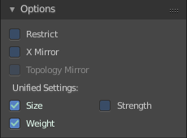
Restrict
Restrict painting to vertices in the group.

X Mirror
X Axis Mirror Editing.

Topology Mirror
Needs X Mirror ticked. Use topology based mirroring. For when both sides of the mesh have matching, unique topology.

Unified Settings

Size
The radius of the brush is shared across brushes.

Strength
The strength is shared across brushes.

Weight
The weight is shared across brushes.

Texture Paint Mode

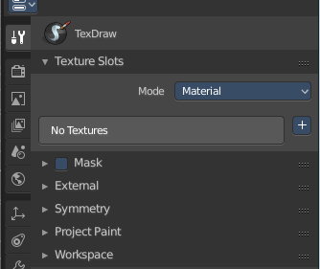
The Texture Paint Mode provides you the tools to paint directly at the texture of your mesh in the viewport. To fix visible seams for example.
The Texture Paint mode is just available for mesh objects.

Requirements
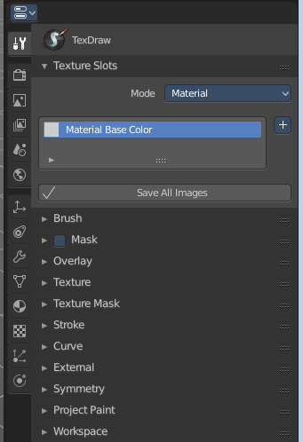
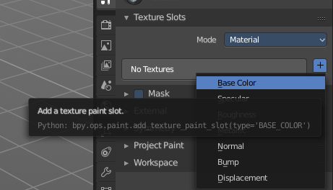
Texture Painting requires to have a working UV mapping and a texture applied. When there is no UV mapping and no assigned texture, then you will get a warning about No Texture. You have to create a texture slot first.

Save Texture
The result of texture painting can be found and be saved in the UV Image Editor. You can also paint in the UV editor.
The modified texture does NOT save with the scene. You have to save out the image when you want to save the changes at the texture. There is no warning. So DON'T FORGET TO SAVE THE TEXTURE.
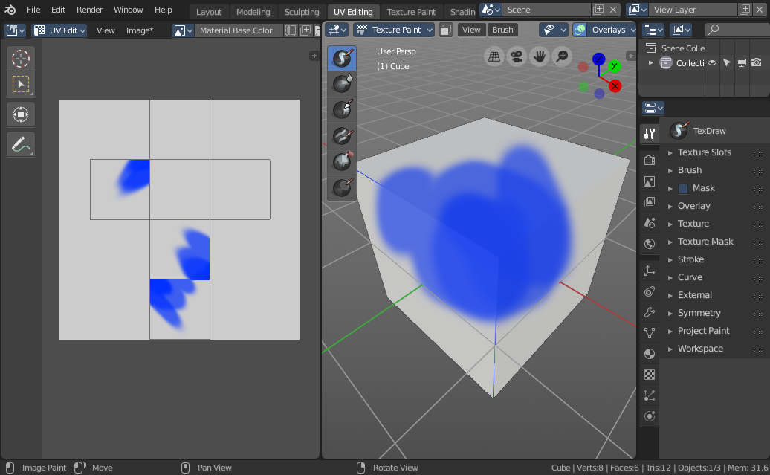

Texture Paint Mode - Texture Slots Panel

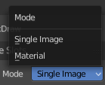
Mode
Here you can choose in which mode you want to paint. Single Image just works with a single image, without any material.
Material works with a material and a texture. The texture is here part of the material.

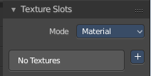
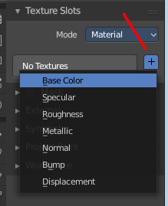
Paint Slot empty
In the texture slot panels you will see the texture slots in use. When the mesh does not have a texture or a material yet then you will get a warning displayed. No Textures.

You can create a simple texture and material here too by clicking at the + button at the right.

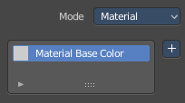
Paint Slot with mode Material

Material Paint Slot
Here you can see the list of the available paint slot materials.

Add Texture Paint Slot
Here you can add more materials to the Material Paint Slot.

Paint Slot with Mode Single Image

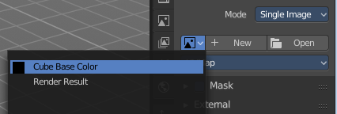
Image List
Here you can find a list of the available images, and choose one.

New/Open
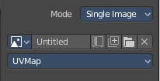
When no image is loaded then you can create a new image here, or load a new image.

Edit Box
Here you can see the name of the image, and edit the name.

Fake User
When enabled then this image will be stored internally. But not the painted changes at it!!

Number of Users
When the image has an user, then you will see the number of users for this image.

New Image
Create a new image

Open Image
Open a image

Unlink Data Block
Delete the Image when saving the scene, closing and reopening Bforartists. Note that the number of Users must be zero. Or the image comes back.

Texture Paint Mode - Brush Panel

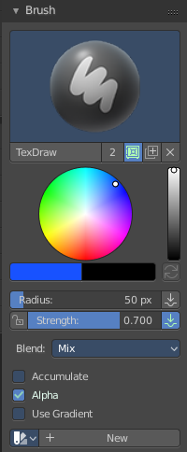
Brush Panel
The Brush Panel contains the different paint brushes, a color dialog, and some brush settings.

At down left you can find the display options. The button with the gear symbol at it. Here you will find two toggles to hide away the color picker and the palette edit box.

< -------- Needs reimplementation!

Browse Brush
The big image at the top is a dropdown box where you can choose a brush. Click at it, and you will see the different brushes. A click at one of the images will choose this brush then.
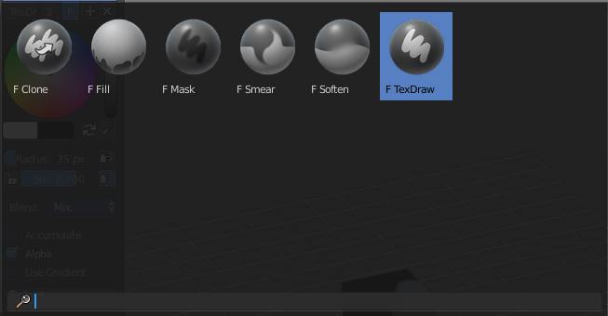
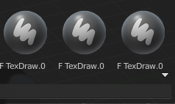
When you have added a few more brushes then the dropdown box may be more than full. You will see some little white arrows then. Either in the top left or in the bottom right corner. They indicate that some brushes are hidden before or after the current display.
To scroll to this hidden content use the mouse wheel, or the arrow up and down buttons at the keyboard.

The edit box below the Image shows you the name of the current active brush.
The number right of it, in this case 2, indicates how much number of users ( internally ) this brush uses. This means that this data block (the brush) shares currently settings with at least one other object. Most probably the parent brush where we have created it from. Click at the value to make this brush a single user. The button will vanish then.
F set the brush to have a fake user. Zero user data-blocks are normally not saved. But sometimes you want to force the data to be kept even when the data block has no user.
The + button allows you to add a new pencil with the current settings. Note that the brushes are NOT saved when you close Bforartists. You can save them into the current blend file. Or you can save the startup file. But be careful here. This saves everything else of the current state of Bforartists too.
The X button deletes the brush as the active one. It does NOT delete it from the brushes list.

Color dialog
Here you can define the color in the color element below the brush browser. It will also open a color dialog then.
When you set it to visible, then you can set the color for painting by a click with the mouse in the color wheel. The slider at the right defines the brightness.
The button below shows you the active color.
A click at the color button will open a more detailed color dialog, where you can set up rgb, hsv and hex colors and with sliders.

Color Element
Here you can set a primary and a secondary color. The button with the arrows at it switches the active and the secondary color. And with the pipette you can pick a color from the screen. This will reveal some more elements, and create a palette. Here you can choose now the color to use it for painting. You can add and remove colors here too.
This color picker can just pick a color in the 3D view. It does not work elsewhere.

Radius
The Radius edit box allows you to adjust the radius of the brush. The button behind the edit box enables tablet pressure sensitivity for radius.
And the button at the end allows you to set the radius of the pencil by hotkey. A click at this button works of course too. But this is a hotkey tool. The button is just a visible reminder.

Strength
The Strength edit box allows you to adjust the strength of the brush. When the Lock symbol at the front is ticked, then the pencil keeps its strength relative to the object when zooming in and out. The button behind the edit box enables tablet pressure sensitivity for strength.
And the button at the end allows you to set the strength by hotkey. A click at this button works of course too. But this is a hotkey tool. The button is just a visible reminder.

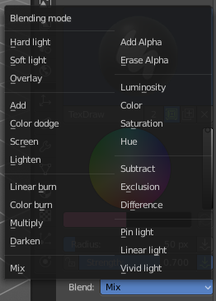
Blend
A dropdown box where you can adjust the blend mode of the paint stroke. Default method is Mix.

Accumulate
Accumulates stroke daubs on top of each other.

Alpha
When unchecked, lock Alpha while painting.

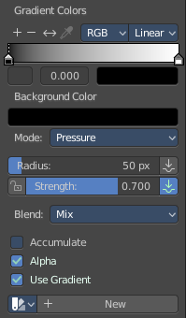
Use Gradient
When you tick Use Gradient then you reveal a Gradient dialog. Here you can set up a gradient.
Important!
Painting a gradient requires to have the Fill pencil chosen. It will not work with the other pencil types.
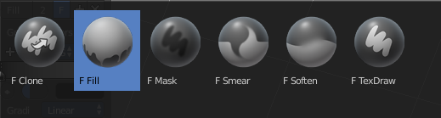

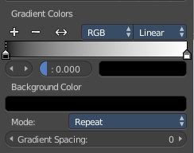
Gradient Colors dialog
The + Button adds a color ramp point. That way you can have more than one color in the gradient.

The - Button removes the currently selected color ramp point.
The <> Element flips the color ramp
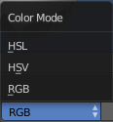
Color Mode is a dropdown box where you can choose the color mode for the gradient.

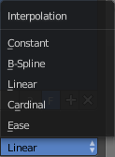
Interpolation is a dropdown box where you can choose the interpolation mode for the gradient.

In the Color Ramp element you will see the color ramp with the single color points.
Choose Active Color Stop is the stop point of the gradient.
Position is a edit box where you can fine tune the position of the currently selected color point

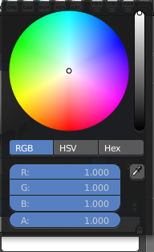
Set Color of selected color stop is the color of the currently selected color point. When you click at it then you will get a color dialog that allows you to setup the color.

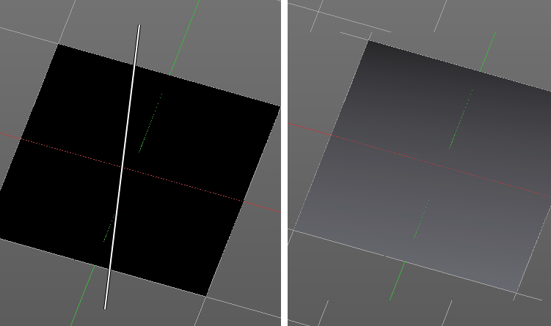
Usage
Set up the gradient in the Gradient dialog.
Choose the Fill pencil. Gradient will not work with other pencils.
Click at the start point of the gradient.
Drag the mouse to the end point of the gradient. This will draw a line that defines the gradient direction.
Release the mouse.

Palette
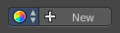
When you pick up a color with the color picker then a palette of colors gets created. This color palette is stored here. You can have more than one palette.
Palettes saves with the scene.
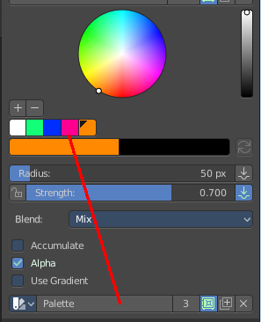
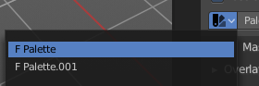

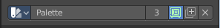
The icon with the color wheel is a dropdown box where you can choose the active palette.

The Palette edit box shows you the current active palette. Here you can also rename it.

The number right of it, in this case 3, indicates how much number of users ( internally ) this palette uses. This means that this data block (the palette) shares currently settings with at least one other object. Most probably the parent palette where we have created it from. Click at the value to make this palette a single user. The button will vanish then.
F set the item to have a fake user. Zero user data-blocks are normally not saved. But sometimes you want to force the data to be kept even when the data block has no user.
The + button allows you to add a new palette with the current settings.
The X button deletes the palette as the active one. You will see the "New" button then. It does NOT delete it from the palette list.

Texture Paint Mode - Mask Panel
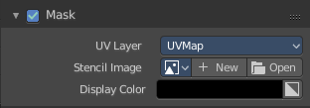
Here you can load a stencil map to mask out parts of the texture. You have to activate it in the panel header.

UV Map
A dropdown box with the UV map to use for image painting. A mesh can have more than one material and more than one UV Map applied.

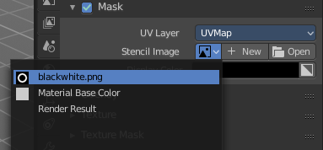
Stencil Image
Here you can choose or create a Image that gets used for the masking. You can choose any image that is loaded.

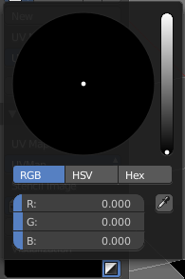
Display Color
You usually want a black n white image for masking. But here you can set up the color for the stencil map. A click at the button opens a color dialog. The button at the right flips the colors.

Texture Paint Mode - Overlay Panel

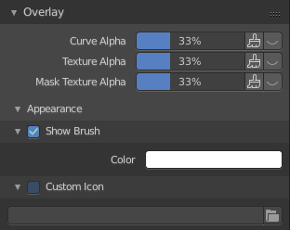

Curve
This setting is interesting for the Stroke method Curve. Here you can adjust how transparent the curve is.
The eye icon button in front of the slider is to show the curve object in viewport. The brush icon button behind the slider is to hide the overlay during a stroke.

Texture
This setting is interesting for Texture painting. Here you can adjust how transparent the texture is.
The eye icon button in front of the slider is to show the texture in the viewport. The brush icon button behind the slider is to hide the overlay during a stroke.

Mask Texture
This setting is interesting for Texture painting. Here you can adjust how transparent the Mask texture is.
The eye icon button in front of the slider is to show the texture in the viewport. The brush icon button behind the slider is to hide the overlay during a stroke.

Appearance
The Appearance subtab provides you with some settings to adjust the appearance of the brush.

Show Brush
Show the brush in 3D view.

Color
The color that the brush cursor has.

Custom Icon
Here you can define a custom icon for the brush.

Texture Paint Mode - Texture Panel
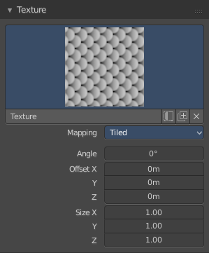

Texture Panel
The Texture panel allows you to paint with textures. This allows you for example to grab a foto from some fish scales, and simply paint them onto the mesh by using this image as a pencil. Or as a blueprint where you calk through ( Stencil method ).

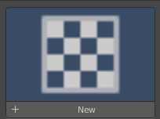
Browse Texture to be linked
The image at the top of the panel is a image browser. Here you can choose a texture that you can choose for painting then. You can also have more than one image loaded at once.

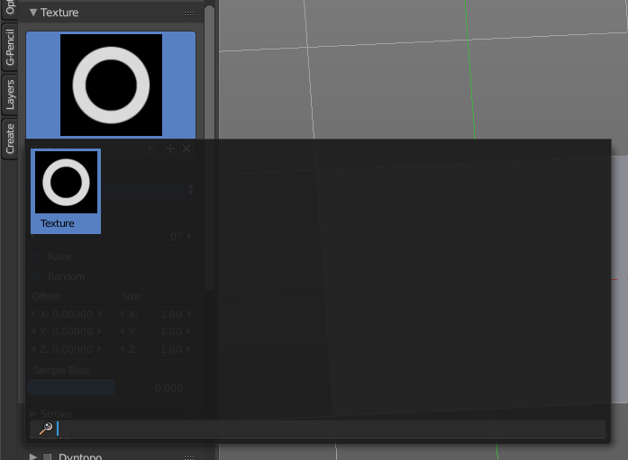
In this shot there is already a texture added. The way to add the texture here is a bit more complicated. And not done with clicking at the New button.

First click at the New button below the image. This will create a new texture slot. This slot is still empty, it displays black.

We need to load a texture in this slot. This must be done in the Properties editor in the Textures tab.

The problem is, we have an object with a material and a texture already selected. And when we change this texture , then we don't get the pencil texture loaded. But we change the texture at our mesh.

What we need to do is to create a material first. And in this material we load our pencil texture then. And then this texture becomes available in the image browser of the Texture panel.

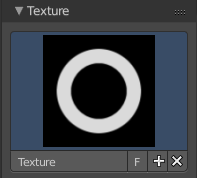
Texture Edit box
The Texture edit box is the edit box below the Image browser. When there's no image loaded then it displays the New button. When there's a image (or more) loaded, then you will see the name of the current texture.
The F button turns this texture into a data block with a fake user. Means it will exists even when there is no data connected to it anymore.
When you activate Fake User, then you may get a value in front of it, which displays how much users this data block (our texture slot) currently has.
The + Button adds another texture slot. Note that you will have to load a texture too, as explained above.
The X button deletes the texture slot.

Brush Mapping
Our texture can be mapped in different methods. The Brush mapping is a dropdown box where you can choose this different brush mapping methods.
The settings vary. So we will go through them by the different brush mapping methods.

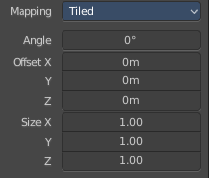
Brush Mapping with mapping method Tiled
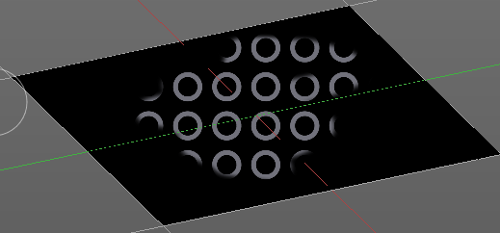
The brush mapping method Tiled tiles the brush stroke at the surface. The mapping happens from the current view. The result may be distorted when the view does not align with the surface of the object.

Angle
The angle of the brush.

Offset
The offset of the texture in the brush.

Size
The size of the texture in the brush.

Brush Mapping with mapping method View Plane
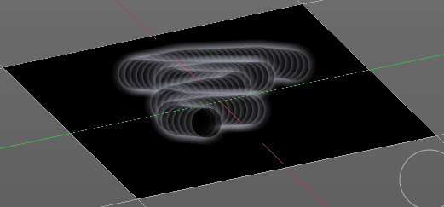
The brush mapping method View Plane simply paints onto the surface. The mapping happens from the current view. The result may be distorted when the view does not align with the surface of the object.

Angle
The angle of the brush.

Rake
The angle follows the direction of the brush stroke.

Random
The brush angle gets set random.

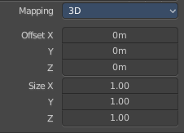
Brush Mapping with mapping method 3D
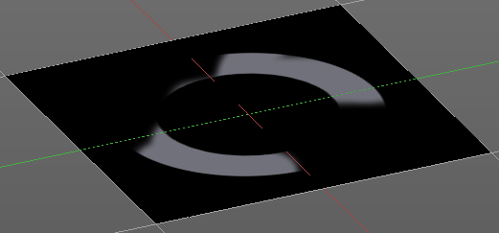
The brush mapping method 3D paints the texture at the surface, by tiling it 1/1 at the object surface.

Offset
The offset of the texture in the brush.

Size
The size of the texture in the brush.

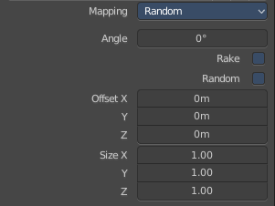
Brush Mapping with mapping method Random
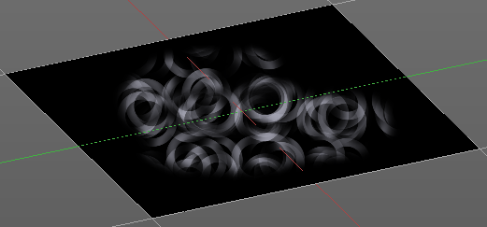
The brush mapping method Random paints onto the surface, and randomizes the texture position in the brush while that. The mapping happens from the current view. The result may be distorted when the view does not align with the surface of the object.

Angle
The angle of the brush.

Rake
The angle follows the direction of the brush stroke.

Random
The brush angle gets set random.

Brush Mapping with mapping method Stencil
The former methods uses the textures for the brush. The method Stencil works different. You have your texture displayed in the workspace above the object, and you paint this texture onto your object with your pencil strokes.
Note that the texture in the 3d space is just visible when you are with the mouse over the viewport.
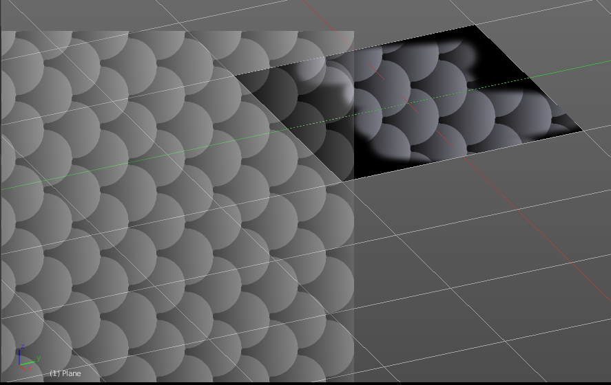
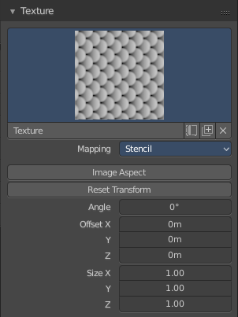

Image Aspect
Adjust the stencil size to fit to the image aspect ratio

Stencil Brush controls
Here you can move, rotate and scale the stencil image in the 3D viewport. And reset the transform. You better use the hotkeys here that gets displayed in the tool tips, since the image is not displayed when the mouse is not over the 3D viewport.

Angle edit box
Here you can adjust the angle of the brush. The button at the end allows you to set the radius by dragging the mouse. This should be done in the viewport and with the hotkey. This button is just a visible reminder.

Offset
Fine tune the offset of the texture in the brush.

Size
Fine tune the size of the texture in the brush.

Texture Paint Mode - Texture Mask Panel

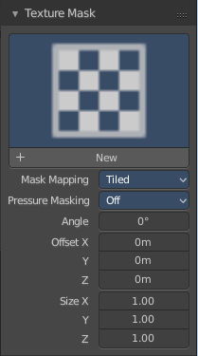
Texture Mask Panel
The texture mask panel allows you to use a texture as a mask to define the strength of painting. In the shot example we use a tiled fishscale Texture as a pencil, and a stencil map as our texture mask. And it paints just where the mask texture is bright. You can of course use gradients here to define the paint strength.

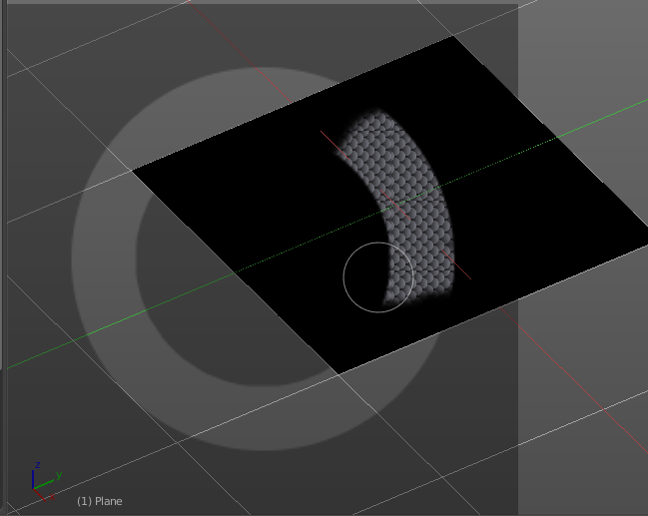

Browse Texture to be linked
The image at the top of the panel is a image browser. Here you can choose a texture that you can choose for painting then. You can also have more than one image loaded at once.

In this shot there is already two textures added. The way to add the texture here is a bit more complicated. And not done with clicking at the New button.
First click at the New button below the image. This will create a new texture slot. This slot is still empty, it displays black.

We need to load a texture in this slot. This must be done in the Properties editor in the Textures tab.

The problem is, we have an object with a material and a texture already selected. And when we change this texture , then we don't get the pencil texture loaded. But we change the texture at our mesh.

What we need to do is to create a material first. And in this material we load our pencil texture then. And then we can choose this texture in the image browser of the texture.

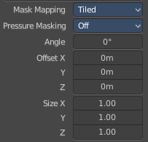
Brush Mapping with mapping method Tiled
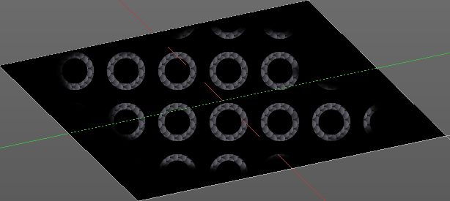
The brush mapping method Tiled tiles the brush stroke at the surface. The mapping happens from the current view. The result may be distorted when the view does not align with the surface of the object.

Mask Pressure Mode
A dropdown box where you can choose the mask pressure mode for tablets.

Angle
The angle of the brush.

Offset
The offset of the texture in the brush.

Size
The size of the texture in the brush.

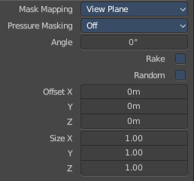
Brush Mapping with mapping method View Plane
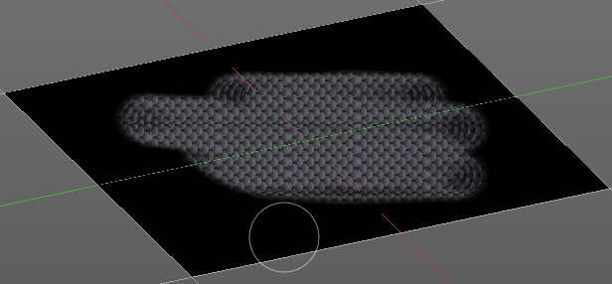
The brush mapping method View Plane simply paints onto the surface. The mapping happens from the current view. The result may be distorted when the view does not align with the surface of the object.

Mask Pressure Mode
A dropdown box where you can choose the mask pressure mode for tablets.

Angle
The angle of the brush.

Rake
The angle follows the direction of the brush stroke.

Random
The brush angle gets set random.

Offset
The offset of the texture in the brush.

Size
The size of the texture in the brush.

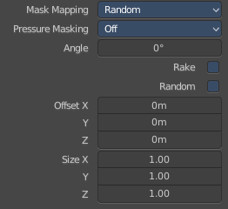
Brush Mapping with mapping method Random
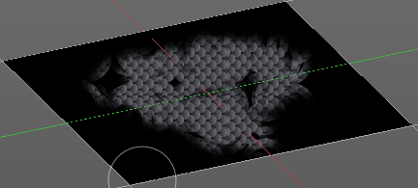
The brush mapping method Random paints onto the surface, and randomizes the texture position in the brush while that. The mapping happens from the current view. The result may be distorted when the view does not align with the surface of the object.

Mask Pressure Mode
A dropdown box where you can choose the mask pressure mode for tablets.

Angle
The angle of the brush.

Rake
The angle follows the direction of the brush stroke.

Random
The brush angle gets set random.

Offset
The offset of the texture in the brush.

Size
The size of the texture in the brush.

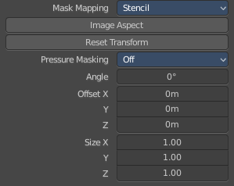
Brush Mapping with mapping method Stencil
The former methods uses the textures for the brush. The method Stencil works different. You have your texture displayed in the workspace above the object, and you paint this texture onto your object with your pencil strokes.

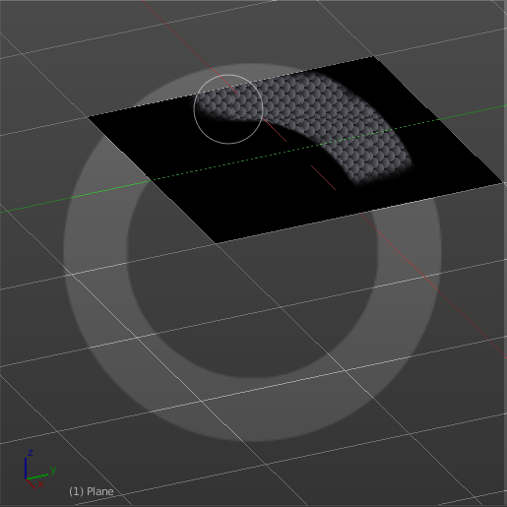
Note that the texture in the 3d space is just visible when you are with the mouse over the viewport.

Mask Pressure Mode
A dropdown box where you can choose the mask pressure mode for tablets.

Stencil Brush controls Secondary
Here you can move, rotate and scale the stencil image from the TEXTURE MASK panel, And reset the transform. You better use the hotkeys here that gets displayed in the tool tips, since the image is not displayed when the mouse is not over the 3D viewport.

Angle edit box
Here you can adjust the angle of the brush. The button at the end allows you to set the radius by dragging the mouse. This should be done in the viewport and with the hotkey. This button is just a visible reminder.

Offset
Fine tune the offset of the texture in the brush.

Size
Fine tune the size of the texture in the brush.

Texture Paint Mode - Stroke Panel

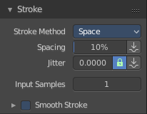
Stroke Panel
The Stroke panel contains settings to influence the behaviour of the brush stroke. There are various stroke methods available. We will go through them one by one.

Stroke Panel with Stroke method Space
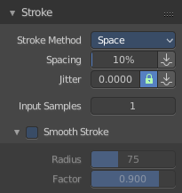
This is the default Stroke method. The sculpt stroke gets added continuously with given settings.
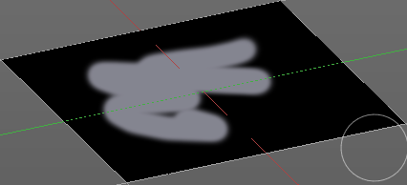

Spacing Edit Box
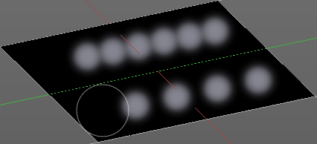
The sculpt drawing happens by mapping the pencil onto the mouse position. And when you move the mouse then the next mapping happens. Here you can adjust the spacing after what mouse movement the next mapping should happen. The lower the value, the lower the distance between the single dots.
The icon behind the edit box enables tablet pressure sensitivity for tablets.

Jitter Edit Box
Here you can add Jitter to the brush while painting.
The icon in front of the edit box toggles between jittering in screen space and relative to brush size.
The icon behind the edit box enables tablet pressure sensitivity for tablets.

Input Samples Edit Box
Average multiple input samples together to smooth the brush stroke.

Smooth Stroke
The brush lags behind the mouse position, and produces a much smoother stroke by that.

Smooth Stroke Radius Edit Box
Is just active when Smooth Stroke is activated. Here you can adjust the radius of the smoothing.

Smooth Stroke Factor Edit Box
Is just active when Smooth Stroke is activated. Here you can adjust the factor of the smoothing.

Stroke Panel with Stroke method Curve
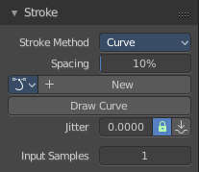
The Stroke method curve doesn't simply influence the way how the stroke is painted. It is a special method. First you draw a curve object by holding down ctrl and clicking with left mouse button. Then you tweak the curve. You can click at the curve point, and drag out handlers to make the curve points smoooth.
Then you hit the Draw Curve button. And the curve gets drawn onto the surface.

Spacing Edit Box
The drawing happens by mapping the pencil onto the mouse position. And when you move the mouse then the next mapping happens. Here you can adjust the spacing after what mouse movement the next mapping should happen. The lower the value, the lower the distance between the single dots.
The icon behind the edit box enables tablet pressure sensitivity for tablets.

Paint Curve edit box
Here you set the active curve.
The first element is a dropdown box where you will find your curves objects. You can have more than one.
The second element is the edit box that displays the active curve.
The number right of it, in this case 2, indicates how much number of users ( internally ) this brush uses. This means that this data block (the brush) shares currently settings with at least one other object. Most probably the parent brush where we have created it from. Click at the value to make this brush a single user. The button will vanish then.
F set the brush to have a fake user. Zero user data-blocks are normally not saved. But sometimes you want to force the data to be kept even when the data block has no user.
The + button allows you to add a new pencil with the current settings. Note that the brushes are NOT saved when you close Bforartists. You can save them into the current blend file. Or you can save the startup file. But be careful here. This saves everything else of the current state of Bforartists too.
The X button deletes the brush as the active one. It does NOT delete it from the brushes list.

Draw Curve Button
A click at it to turns the curve into a sculpt stroke.

Jitter Edit Box
Here you can add Jitter to the brush while painting.
The icon in front of the edit box toggles between jittering in screen space and relative to brush size.
The icon behind the edit box enables tablet pressure sensitivity for tablets.

Input Samples Edit Box
Average multiple input samples together to smooth the brush stroke.

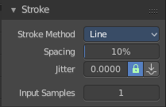
Stroke Panel with Stroke method Line
With Stroke method line you draw a line between a starting point and a endpoint. And when you release the mouse then the line gets sculpted.

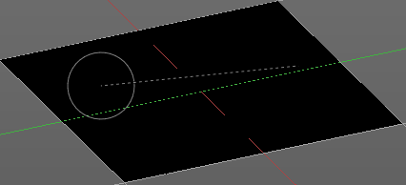
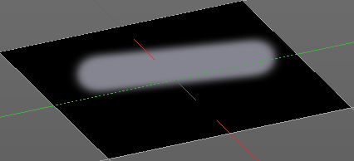

Spacing Edit Box
The drawing happens by mapping the pencil onto the mouse position. And when you move the mouse then the next mapping happens. Here you can adjust the spacing after what mouse movement the next mapping should happen. The lower the value, the lower the distance between the single dots.
The icon behind the edit box enables tablet pressure sensitivity for tablets.

Jitter Edit Box
Here you can add Jitter to the brush while painting.
The icon in front of the edit box toggles between jittering in screen space and relative to brush size.
The icon behind the edit box enables tablet pressure sensitivity for tablets.

Input Samples Edit Box
Average multiple input samples together to smooth the brush stroke.

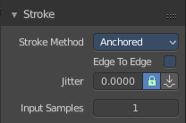
Stroke Panel with Stroke method Anchored
Click and drag to place a dot and to scale it.

Edge to edge
Drag Anchor Brush from edge to edge.

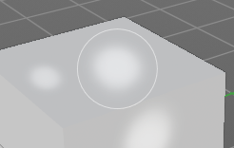
Jitter
Adds a jitter to the dot.

Input Sample Edit Box
Average multiple input samples together to smooth the brush stroke.

Stroke Panel with Stroke method Airbrush
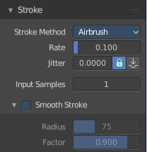
The stroke acts like an airbrush pencil. The dots gets placed randomly.
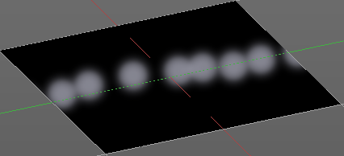

Rate Edit Box
Here you can define the rate of the drawing.

Jitter Edit Box
Here you can add Jitter to the brush while painting.
The icon in front of the edit box toggles between jittering in screen space and relative to brush size.
The icon behind the edit box enables tablet pressure sensitivity for tablets.

Input Samples Edit Box
Average multiple input samples together to smooth the brush stroke.

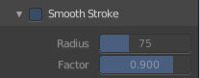
Smooth Stroke
The brush lags behind the mouse position, and produces a much smoother stroke by that.

Smooth Stroke Radius Edit Box
Is just active when Smooth Stroke is activated. Here you can adjust the radius of the smoothing.

Smooth Stroke Factor Edit Box
Is just active when Smooth Stroke is activated. Here you can adjust the factor of the smoothing.

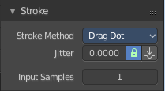
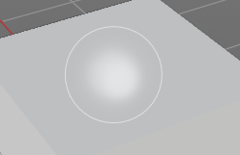
Stroke Panel with Stroke method Drag Dots
Paint a dot and drag it around. The actual painting happens then at releasing the mouse

Jitter Edit Box
Here you can add Jitter to the brush while painting.
The icon in front of the edit box toggles between jittering in screen space and relative to brush size.
The icon behind the edit box enables tablet pressure sensitivity for tablets.

Input Samples Edit Box
Average multiple input samples together to smooth the brush stroke.

Stroke Panel with Stroke method Dots
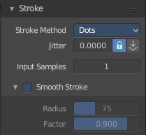
The stroke method Dots draws dots of the pencil onto the surface. The mapping happens from the current view. Means you will get distortions when your view is not aligned with the surface of the object.

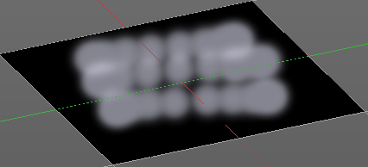
Jitter Edit Box
Here you can add Jitter to the brush while painting.
The icon in front of the edit box toggles between jittering in screen space and relative to brush size.
The icon behind the edit box enables tablet pressure sensitivity for tablets.

Input Samples Edit Box
Average multiple input samples together to smooth the brush stroke.

Smooth Stroke
The brush lags behind the mouse position, and produces a much smoother stroke by that.

Smooth Stroke Radius Edit Box
Is just active when Smooth Stroke is activated. Here you can adjust the radius of the smoothing.

Smooth Stroke Factor Edit Box
Is just active when Smooth Stroke is activated. Here you can adjust the factor of the smoothing.

Texture Paint Mode - Curve Panel
The curve panel allows you to define different fallofs methods for the border of the brush.

Navigation elements
The navigation elements at the top are described from left to right.

Zoom in and out
The two buttons with the magnifying glass at it zooms in and out in the curve window.

Tools
Tools is a menu where you can find some cuve related tools.

Reset View
Resets the curve windows zoom.

Vector Handle
Set handle type to Vector.

Auto Handle
Set handle type to Auto.

Auto Clamped Handle
Set handle type to Auto Clamped.

Reset Curve
Resets the curve to the initial shape.

Use Clipping
Clipping options. Here you can set up clipping for the stroke.

Delete Points
Deletes selected curve points

Curve Presets
Here you can find some predefined curve presets.

Texture Paint Mode - External Panel
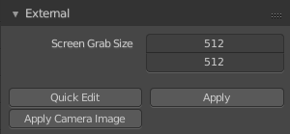
The external panel allows you to do projection painting by using an external 2d image editor. The projection happens from the current view. So this can lead to distortions.

Resolution
Here you can set the resolution of the shot.

Quick Edit
Opens a shot of the current view in your 2D Image Editor.

Apply
Applies the changes that you made and saved in your 2D Image Editor.

Apply Camera Image
Project an edited render from the active camera back onto the object.
This feature requires to have a background image loaded. Then this background image can be projected onto the object from the camera view.

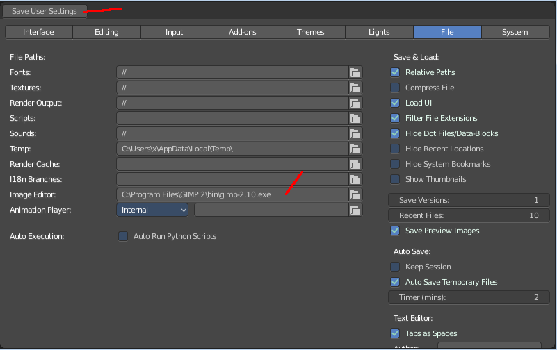
Workflow

Preparations
You first have to link your software that you want to use here. When there is no image editor linked then you will get a warning.
Open the User Preferences, go to the File tab. Here choose the Image Editor section, and browse for your image editor. I have chosen Gimp here at Windows 7.

Don't forget to save the User Settings!
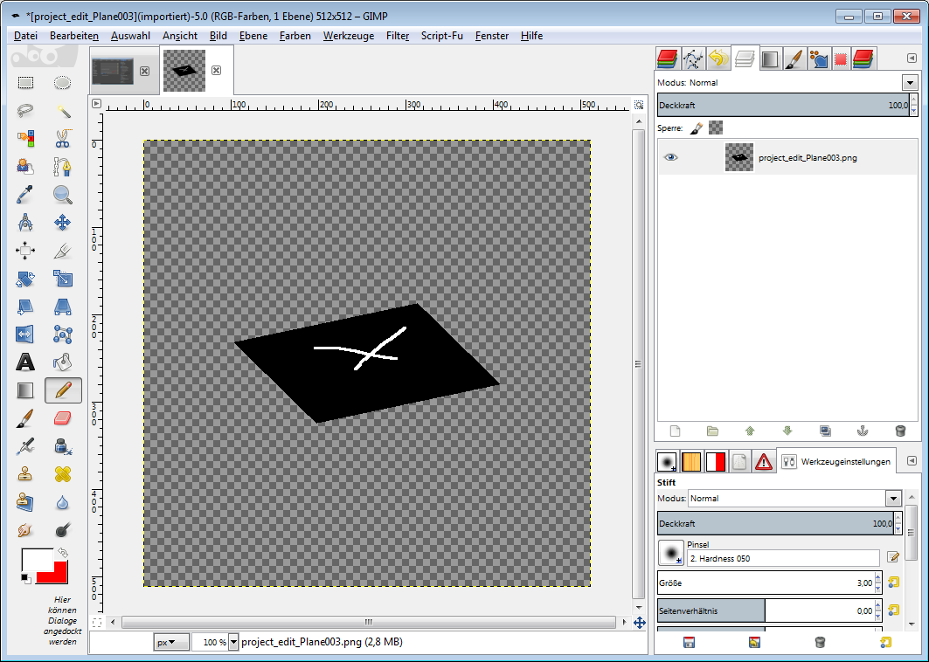
For further options have a look in the Project Paint panel.

Usage

Click at the Quick Edit Button. And your image editor will open up with a shot from the current view. Modify your image.

When done simply overwrite the image. Sorry for the german shot ...

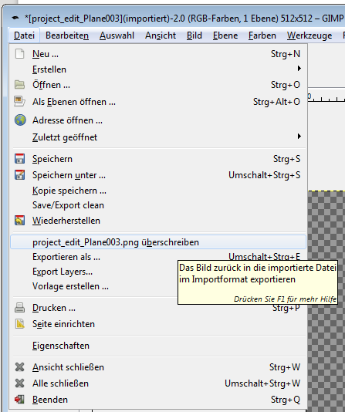
Back in Bforartists click at the Apply button. And the result gets mapped onto your object.

Attention, don't change the camera view while doing this. Mapping happens from the current camera view!

Texture Paint Mode - Symmetry Panel

Symmetry Panel
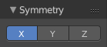
Here you can turn on/off symmetry painting along X, Y and Z axis. The mirroring happens along the world axis.
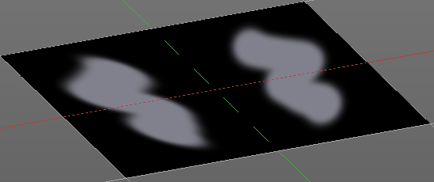

Texture Paint Mode - Project Paint Panel

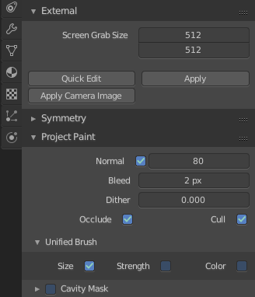
The Project Paint panel contains the settings for the External painting panel from the Tools tab.

Normal
This defines the angle after which the painting is not applied anymore. That way you can avoid heavy distortions at higher angles since it projects from the current view.

Bleed
An edit box to adjust the amount of bleeding into the areas outside of the faces uv.

Dither
An Edit box to adjust the amount of dither when painting on byte images

Occlude
Only paint the faces directly under the mouse

Cull
Ingore faces that points away from the current view.

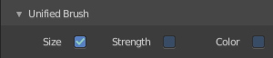
Unified Brush
Unified Brush is a subtab menu with some global brush settings.

Size
Instead of per Brush radius, the radius is shared across brushes.

Strength
Instead of per Brush strength, the strength is shared across brushes.

Color
Instead of per Brush color, the color is shared across brushes.

Cavity Mask
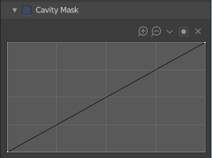
Cavity mask allows mask painting according to mesh geometry cavity. It is a submenu tab. In expanded state it shows the falloff curve, which can be edited.

Navigation elements
The navigation elements at the top are described from left to right.

Zoom in and out
The two buttons with the magnifying glass at it zooms in and out in the curve window.

Tools
Tools is a menu where you can find some cuve related tools.

Reset View
Resets the curve windows zoom.

Vector Handle
Set handle type to Vector.

Auto Handle
Set handle type to Auto.

Auto Clamped Handle
Set handle type to Auto Clamped.

Reset Curve
Resets the curve to the initial shape.

Use Clipping
Clipping options. Here you can set up clipping for the stroke.

Delete Points
Deletes selected curve points.

Particle Edit Mode
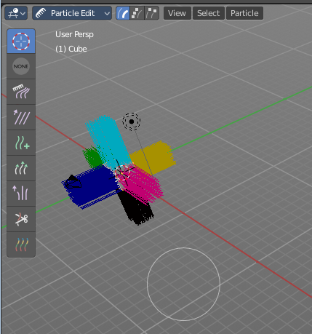
The Particle Edit mode enables to edit particle settings. For example, Hair Particles can be manipulated with some brushes. They can be combed, cut etc.

The Tools tab contains the settings for the hair editing brushes.

Particle Edit Mode - Brush panel
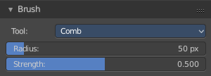
There are some general settings for all brushes. And there are some brush specific settings.

General Settings

Tool
The current brush. Usually you select it in the tool shelf.

Radius
The brush radius.

Strength
The brush strength.

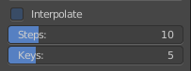
Add Brush

Interpolate
Interpolate new particles from existing ones.

Step
The number of new particles

Keys
With how many keys the new particles are created.

Length Brush

Grow /Shrink
Make the hair particles longer or shorter.

Puff Brush

Add / Subtract
Makes the volume fuller or smaller.

Puff Volume
Apply the puff also to unselected end points.

Particle Edit Mode - Options panel

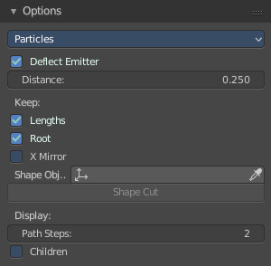
Here you can find some further options for the particles.

Note that you need to bake some particle types to be able modify them. Emitter for example. You will get a warning then, and the Options panel content is greyed out.
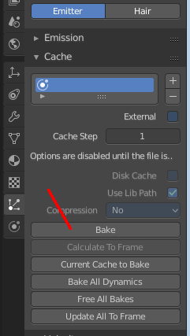
The particles can be baked in the Particles tab in the Cache panel.
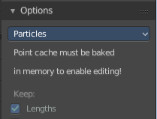

Particle Edit Type
The Particle Edit Type.

Deflect Emitter
Keep Paths from intersecting the emitter object.

Distance
The Distance to keep the particles away from the emitter object.

Keep

Lengths
Keep Path lengths constant

Root
Keep root keys unmodified.

X Mirror

Mirrors the selected particles.
If you want a symmetrical haircut, first select all particles, then mirror the particles, then tick X Mirror in the Particle panel.

Shape
Define a outer shape object to use for tools.

Shape Cut
Is connected with Shape, Cut hair to conform to the defined shape object.

Display

Path Steps
How many steps a path should draw.

Children
Draw actual particles.

Grease Pencil

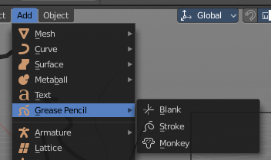
The Grease Pencil allows you to draw in 2D in the workspace.

The Grease pencil is a object type. First you create a grease pencil object. Then you switch to paint mode to paint the strokes. And further editing in other modes happens afterwards then.

In the Tools tab you will find all the options and settings for drawing and manipulating the grease pencil object, means your drawing.

The type Blank allows you to draw strokes.
The type Stroke allows you to draw filled forms.
The type Monkey is just an example, and will be removed soon. It is too confusing since it is just an example, and not a grease pencil object type.

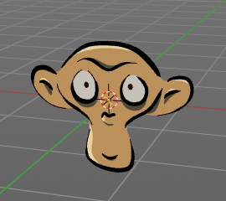
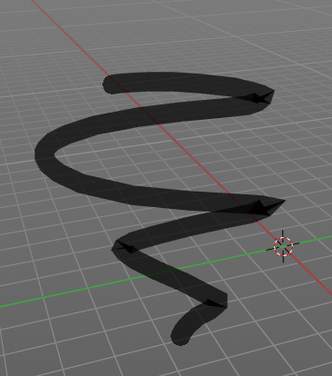
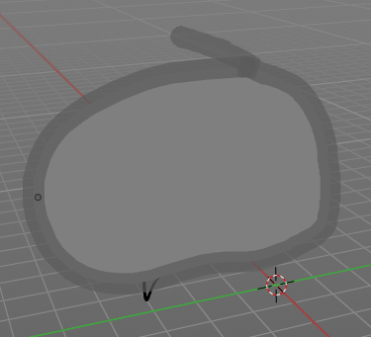

Grease Pencil - Draw Mode - Brush Panel
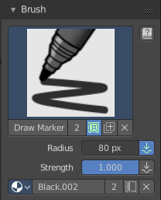

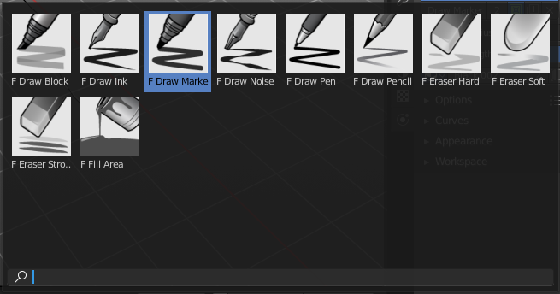
Brush Browser
Here you can choose between the different brushes. It's the same than in the tool shelf.

Create Presets
Here you can create a brush preset set.

Not documented. Not to find out how this one works. Waiting for the Blender manual here ...

Brush Name Edit Box
The edit box below the Image shows you the name of the current active brush.
The number right of it, in this case 2, indicates how much number of users ( internally ) this brush uses. This means that this data block (the brush) shares currently settings with at least one other object. Most probably the parent brush where we have created it from. Click at the value to make this brush a single user. The button will vanish then.
The odd symbol right of it set the brush to have a fake user. Zero user data-blocks are normally not saved. But sometimes you want to force the data to be kept even when the data block has no user.
The + button allows you to add a new pencil with the current settings. Note that the brushes are NOT saved when you close Bforartists. You can save them into the current blend file. Or you can save the startup file. But be careful here. This saves everything else of the current state of Bforartists too.
The X button deletes the brush as the active one. It does NOT delete it from the brushes list.

Radius
The Radius edit box allows you to adjust the radius of the brush. When the Lock symbol at the front is ticked, then the pencil keeps its size relative to the object when zooming in and out. The button behind the edit box enables tablet pressure sensitivity for radius.
And the button at the end allows you to set the radius of the pencil by hotkey. A click at this button works of course too. But this is a hotkey tool. The button is just a visible reminder.

Strength
The Strength edit box allows you to adjust the strength of the brush. When the Lock symbol at the front is ticked, then the pencil keeps its strength relative to the object when zooming in and out. The button behind the edit box enables tablet pressure sensitivity for strength.
And the button at the end allows you to set the strength by hotkey. A click at this button works of course too. But this is a hotkey tool. The button is just a visible reminder.

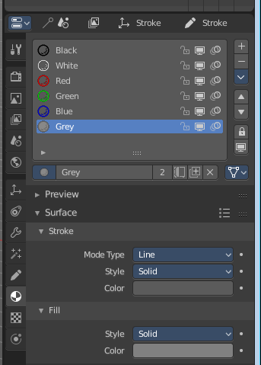
Material Browser
The colors for the grease pencil are materials each. For the grease pencil type Blank you will just have one color available. For this type you have to cteate new matertials in the material tab first when you need more colors. But the other two types, strokes and monkey, comes with a few base materials already.

Dropdown box
Here you can choose another material to draw with.
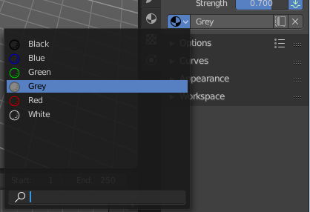

Edit Box
Here you can read and modify the material name.
F set the material to have a fake user. Zero user data-blocks are normally not saved. But sometimes you want to force the data to be kept even when the data block has no user.
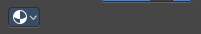
The X button deletes the material as the active one. It does NOT delete it from the materials list.

Grease Pencil - Draw Mode - Options Panel
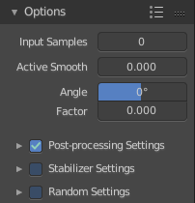
Here you can find some grease pencil related options.

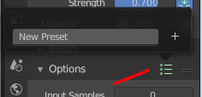
Presets
In the header you can find a presets menu. Here you can store your own presets, and reuse them at a later point.

Input Samples
Generate intermediate Points for very fast mouse movements. A value of 0 means this feature is disabled.

Active Smooth
The amount of smoothing the strokes while drawing.

Angle
Direction of the stroke at which it gives the biggest thickness.

Factor
Reduce the brush thickness by this amount when the stroke is perpendicular to "Angle" direction.

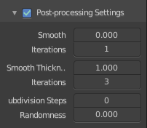
Post Processing Settings
Post processing settings is a sub menu. Here you can enable some post processing steps to manipulate the strokes that you currently draw.
You can activate or deactivate it by the checkbox in the header.
Note that you need to have this one enabled when you draw the stroke. It cannot manipulate already created stokes. Just the ones that you currently paint.

Smooth
Smooth the stroke form.

Iterations
How much iterations to use for smoothing.

Smooth Thickness
Smooth the stroke thickness

Iterations
How much iterations to use for smoothing.

Subdivision Steps
Subdivide the strokes.

Randomness
Randomness for subdivision.

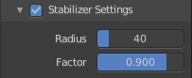
Stabilizer Settings
Stabilizer Settings is a sub menu. Here you can find some further stabilization settings.
You can activate or deactivate it by the checkbox in the header.

Radius
Minimum radius from last point before drawing continues.

Factor
Smooth stroke factor. Higher values gives a smoother stroke.

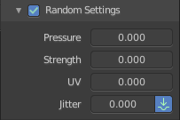
Random Settings
Random Settings is a sub menu. Here you can find some functionality to randomize your strokes.
You can activate or deactivate it by the checkbox in the header.

Pressure
Randomize the pressure.

Strength
Randomize the strength.

UV
Random factor for auto generated UV Rotation.

Jitter
Add some jitter to the strokes.

Grease Pencil - Draw Mode - Curves Panel
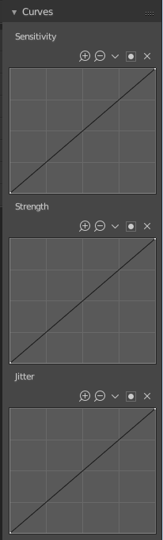
Here you can see and manipulate the curves for drawing Sensitivity, Strength and Jitter.

The navigation elements are the same for all three curve types.

Navigation elements
The navigation elements at the top are described from left to right.

Zoom in and out
The two buttons with the magnifying glass at it zooms in and out in the curve window.

Tools
Tools is a menu where you can find some cuve related tools.

Reset View
Resets the curve windows zoom.

Vector Handle
Set handle type to Vector.

Auto Handle
Set handle type to Auto.

Auto Clamped Handle
Set handle type to Auto Clamped.

Reset Curve
Resets the curve to the initial shape.

Use Clipping
Clipping options. Here you can set up clipping for the stroke.

Delete Points
Deletes selected curve points.

Grease Pencil - Draw Mode - Appearance Panel
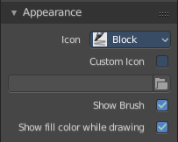

Icon
A dropdown box where you can choose the brush that you want to alter.

Custom Icon
Here you can define a custom icon for the brush.

Show Brush
Show the brush icon while drawing

Show Fill Color while drawing
Show the fill color while drawing. This one affects the Grease pencil type Stroke.

Grease Pencil - Edit Mode

No content yet when you are in edit mode. Waiting for the official Blender manual here ...

Grease Pencil - Sculpt Mode

In Sculpt mode you can sculpt the grease pencil strokes.

Grease Pencil - Sculpt Mode - Brush Panel

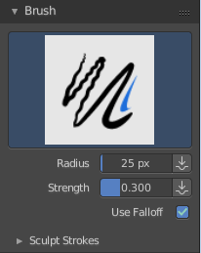
Brush browser
Here you can pick a pencil, and see what pencil is active.
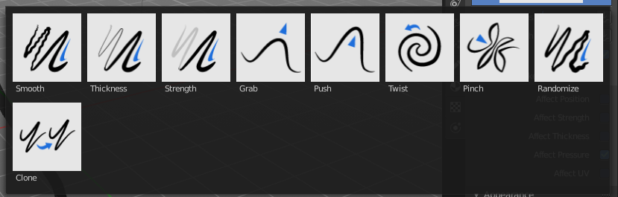

Radius
The radius of the brush.

Strength
The strength of the brush.

Use Falloff
Use Falloff for the brush.

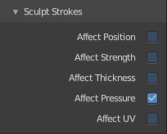
Sculpt Strokes
Sculpt Strokes is a submenu with further settings.

Affect position
The brush affects the position of the points.

Affect strength
The brush affects the color strength.

Affect thickness
The brush affects the stroke thickness

Affect pressure
Affect pressure values as well when smoothing strokes

Affect UV
The brush affects the UV rotation of the points.

Grease Pencil - Sculpt Mode - Appearance Panel
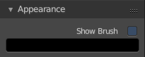

Show Brush
Show the brush icon when painting.

Color
The brush icon color.

Grease Pencil - Weight Paint Mode

In Weight Paint Mode you can weight paint your strokes.

Grease Pencil - Weight Paint Mode - Brush Panel

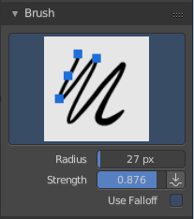
Brush browser
Here you can pick a pencil, and see what pencil is active. There is just one pencil available for weightpainting.
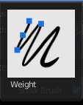

Radius
The radius of the brush.

Strength
The strength of the brush.

Use Falloff
Use Falloff for the brush.

Grease Pencil - Weight Paint Mode - Appearance Panel

Show Brush
Show the brush icon when painting.

Color
The brush icon color.

